Chapter –ii
Literature review

2.1 History and distribution of Pearl Millet
Pearl Millet Pennisetum typhoides is a native of Africa and is reported to have been introduced in India later. It belongs to gramineae family. There are divergent views regarding the origin of this crop. It is mostly cultivated in dry and semiarid tropical regions of Africa, India and China. It is also cultivated in South America, USA, Canada, Italy, Japan and Australia (Manjunath, 1966).
In India millets occupy fourth place next to rice, jowar and wheat and approximately 10.7 million hectares of land is under its cultivation. The important states in India cultivating this crop are Rajasthan, Gujarat, Maharashtra, Punjab, Uttar Pradesh, Andhra Pradesh, Madras, Mysore and Madhya Pradesh. In Andhra Pradesh, it is cultivated in Nalgonda, Ananthapur, Chitoor and Guntur Districts. The productivity of this crop has increased from 303kg/ha during 1951-55 to 630 kg/ha during 1990-95 (Bhatnagar et al., 1998). According to the survey reports of Indian Agricultural (1999), in 1996-97 production of over 7.91 million tones was achieved. The yield was reported to be 791 kg/ha. The increase in productivity is mainly due to the cultivars and open pollinated varieties, coupled with agrom6nomic practices. Bhatnagar et al (1998), listed the varieties of pearl millet released in India between 1965 and 1997. Table 2.1 represents the crop yield of various crops that could be used for ethanol production, their fermentable sugars and the ethanol yield that could be obtained from them.

2.2 Types of millets
The millet varieties can be divided into two categories: Pearl millets and small millets. Pearl millet (Pennisetum glaucum, P.typhoides, P.typideum, P.americanum) is the most widely cultivated among the millet varieties. It is also known as bulrush millet, babila, bajra, cumbu, dulclu, gero, sajje, sanio or sonna based upon the place of cultivation (The World Sorghum and Millet economics, 1996).

2.3 Composition of Pearl millets
Structure, properties and composition of millet grains were extensively reviewed by Hoseney et al (1981) and Sergio Serne-Saldivar and Lloyd W.Rooney (1995). Pearl millets are reported to contain a higher protein content but low starch content. The approximate composition of pearl millet and its nutritional digestibility in comparison with other cereal grains has been
Table 2.1 Ethanol yield from various crops
Crop | Crop yield  (tonne ha⁻¹) | Fermentable carbohydrate  (% fresh wt.) | Ethanol Yield  (l tone⁻¹)
Banana | 12-50 | 18-20 | 93-104
Cane molasses | 2.4 – 4 | 50 | 258 – 291
Cashew apple |  | 11.6 | 60-68
Cassava | 8.7 | 30 | 172-194
Cocoa pulp |  | 13.4 | 70-78
Corn (maize) | 3.2 | 60 | 345-388
Mango |  | 15 | 58-66
Millet | 6.0 | 72 | 414-466
Nipa palm |  | 17 | 88-99
Pine apple | 30 | 14 | 43-49
Potato | 1.6 | 17 | 98-110
Rice | 2.6 | 73.4-80.8 | 422-478
Sorghum | 1.3 | 68-74 | 391-440
Sugar cane | 5.6 | 13-14 | 67-76
Sweet potato | 8.3 | 27 | 154-173
Tannia | 20 | 17-26 | 98-110
Taro (dasheen) | 7.5-37 | 13-29 | 74-84
Yam | 7.5-30 | 15-25 | 86-97

Source: Adam and Flynn, 1982

reported by Chavan and Kadam (1989). Generally pearl millets contain 54-70% carbohydrates, 8.1-13.9 % protein, 4 – 7.3% fat, 1.2-2.3 minerals and 0.6 – 1.6% fibre. The composition varies with the variety of millets chosen (Malleshi and Desikachar, 1986, Hadimani et al, 1995). Gopalan et al (1989) reported the approximate composition of pearl millets in comparion with few commonly used cereals (Table 2.3).

2.3.1 Protein
The various protein fractions of pearl millet and their aminoacid compositions have been reported by Nwasike et al (1979) and Mamta Chandran and Narendra K.Matta (1991). Prolamines and glutalins constitute 75% of the total protein. Lysine and tryptophan were reported to be highest in the albumins and lowest in the globulin fractions. The aminoacid composition of pearl millet was found to be comparable to that of wheat, barley and rice (Ejeta et al, 1987).
The essential and the non-essential amino acids composition of pearl millet is listed in table 2.4.

2.3.2 Carbohydrate
Pearl millet is also a good source of carbohydrates. Starch is the major carbohydrate present and it ranges from 62.8 to 70.2%. The starch contains about 20-22% amylase and 78-80% amylopectin (Beleia et al, 1980). The total soluble sugars range from 2.16 to 2.78. Pearl millets also contain a high proportion of stachyose, raffinose and sucrose.
The soluble sugar contains 0.006 – 0.10% stachyose, 0.65-0.86% raffinose, 1.32 – 1.82 % sucrose and 0.08-0.16% glucose+fructose (Subramanian et al, 1981). The non-starchy polysaccharides of pearl millets range from 18.3-22.0%. Of this hemicelluloses content ranges from 10.4-12.27%, cellulose 5.84-6.84% and lignin 1.15-2.24% (Kamath and Belavady, 1980).

2.3.3 Lipids
Pearl millets contain high proportion (3.0 – 7.0%) of lipids as compared to other cereals (Sharma ad Goswami, 1969). Nigerian millets were reported to contain 7.5% lipid content (Andy R.Opoku et al, 1981). Reports on the fatty acid composition of pearl millet indicate that it

Table 2.2 Types of Millets
Common name | Botanical name | Area of cultivation
Pearl millet | Pennisetum typhoides | Africa, India, Pakistan etc.
Small millets
Finger millets (Ragi) | Eleusine corocana | India , Nepal
Proao or common millet | Panicum miliaceum | Russia, Ukraine, Kazhakastan, USA, Argentina and Australia
Foxtail millets | Setaria italic | China, India, Indonesia, Korea and some parts of Europe
Teff | Eragrostis tef | Ethiopian high lands
White fonio | Digitaria exilis | Nigeria, Southern Mali, Western Bukina Fosa, Sunegal and Guinea
Black fonio | Digitaria iburua | Nigeria and parts of Togo and Benin
Guinea millet | Brachiaria deflexa | Guinea and Sierra Loene
Minor millets
Barnyard millet | Echinochloa crusgalli, E.colona | Tropicsw and subtropics of India
Little millets | Panicum sumatrense | India, Nepal, Pakistan, Srilanka, Eastern Indonesia and Western Myanmar
Kodo millets | Paspalum scrobiculatum | Western Africa and India
Job’s tears | Coix lachrymal-jobi | South east Asia

Source: The World sorghum and millet economics, 1966; Brunken et al, 1977; Rachie and Majmudar, 1980)

Table 2.3 Proximate composition of pearl millet and other cereals ( per 100g edible matter)
Composition | Pearl millet | Wheat | Rice | Maize | Sorghum | Finger millet
Moisture (g) | 12.4 | 12.8 | 13.7 | 14.9 | 11.9 | 13.1
Protein  (N x6.25x g) | 11.6 | 11.8 | 6.8 | 11.1 | 10.4 | 7.3
Fat (g) | 5.0 | 1.5 | 0.5 | 3.6 | 1.9 | 1.3
Minerals (g) | 2.3 | 1.5 | 0.6 | 1.5 | 1.6 | 2.7
Fibre (g) | 1.2 | 1.2 | 0.2 | 2.7 | 1.6 | 3.6
Carbohydrate (g) | 67.5 | 71.2 | 78.2 | 66.2 | 72.6 | 72
Energy (Kcal) | 361 | 346 | 345 | 342 | 3.49 | 328
Calcium (mg) | 42 | 41 | 10 | 10 | 25 | 344
Phosphorus (mg) | 296 | 306 | 160 | 348 | 222 | 283
Iron ( mg) | 8.0 | 5.3 | 0.7 | 2.3 | 4.1 | 3.9
Carotene (μg) | 132 | 64 | 0 | 90 | 47 | 42
Thiamine (mg) | 0.33 | 0.45 | 0.06 | 0.42 | 0.37 | 0.42
Riboflavin (mg) | 0.25 | 0.17 | 0.06 | 0.10 | 0.13 | 0.19
Niacin (mg) | 2.3 | 5.5 | 1.9 | 1.8 | 3.1 | 1.1

Source: Gopalam et al., 1989.

Table 2.4 Amino acid composition of pearl millets
Aminoacids | Concentration range  (gm/100gm protein)
Essential aminoacids
Phenyl alanine | 5.3 – 5.6
Histidine | 2.2 - 2.4
Isoleucine | 4.3 – 4.4
Leucine | 10.9 – 12.2
Lysine | 2.8 – 3.3
Methionine | 2.2 – 2.9
Threonine | 3.9 – 4.4
Tryptophan | 1.1 – 1.9
Valine | 5.7 – 6.0
Non – essential amino acids
Asparatic acid | 8.7 – 9.5
Glutamic acid | 20.8 – 22.1
Alanine | 8.5 – 8.8
Arginine | 3.9 – 4.8
Cystine | 0.9 – 1.5
Glycine | 3.2 – 3.7
Proline | 4.9 – 5.3
Tyrosine | 2.4 – 3.2

(Source: Ejeta et al., 1987; Sergio Serna – Saldivar and Lloyd W. Rooney, 1995)

contains more of unsaturated fatty acids than saturated fatty acids when compared to other cereals (Rooney, 1978).
Free lipids and bound lipids were reported to be in the ranges of 5.55 to 7.08% and 0.57 t0 0.9% (Lai and Varriano-Marston, 1980). Unsaturated fatty acids were reported to be averaging 70.3% of fatty acids of the free lipids and 51.7% of the fatty acids of bound lipids. Fatty acid composition of oil extracted from pearl millet seeds was found to contain high amounts of linoleic, oleic and palmitic acids (Jellum and Powell, 1971). The fatty acid composition is listed in table 2.5.
Osagie and Kates (1984), reported that the lipids of pearl millets contain about 85% neutral lipids, 12% phospholipid and 3% glycolipids. The neutral lipids contain about 85% triglycerides and small amounts of mon- and diglycerides, sterols and fattyacids.

2.3.4 Minerals
Pearl millet contains fairly high amount (1.46-3.88%) of minerals (Deosthale et al, 1977). Calcium and phosphorus are high in concentration when compared to rest of the elements, approximately 372mg calcium and 265mg phosphorus per 100gm of millet seeds are found (Malleshi and Desikachar, 1986). Other mineral elements include (in μg) Iron (8.0 + 0.75, Zinc (31.4 + 2.00), Manganese (11.5 + 0.42), Copper (10.6 + 0.58), Molybdenum (0.69 + 0.58) and Chromium (0.23 + 0.01) per gram of peal millets (Sankara Rao and Deosthale, 1983).

2.3.5 Vitamins
Pearl millet is a rich source of vitamin B and major concentration is reported to be in the germ (Adrian and Sayerse, 1956). Chitre et al (1955) found pearl millet to contain 0.39mg of thiamine, 0.19mg riboflavin and 4.43mg of nicotinic acid per 100gm of E.P. it also contains exceptionally high amounts of choline and vitamin A. Malting and fermentation will increase the amount of vitamin B and their availability. Significant loss occurs as a result of cooking, but Cipo G.Simwemba et al (1984), reported that on cooking the extractability of vitamin B increases and hence they found an increase in vitamin B after cooking.

Table 2.5 Percentage of Fatty acids in pearl millets
Fatty acid | Percentage
Palmitic acid | 16.7 to 25.0
Stearic acid | 1.8 to 8.0
Oleic acid | 20.2 to 30.6
Linoleic acid | 40.3 to 51.7
Linolenic acid | 2.3 to 5.8
Arachidic acid | 0.3 to 0.95

Source : Jellum and Powell, 1971.

2.3.6 Antinutritional factors
Polyphenols, phytic acid, goitrogenic components and galactose containing oligosaccharides are some of the antinutritional factors that are present in pearl millets. They do not contain inhibitory tannins.
Millets change color reversibly from grey to yellow-green at alkaline pH and partially reversibly from grey to cream white under acidic conditions due to the presence of glucosylvitexin, glucosylorietin and vitexin (Rcichert, 1979). Phytic acid content was reported to be reduced during germination or malting. This may be due to the production of Phytases ( Lasztity and Lasztity, 1990). The primary role of phytases may be for strong phosphoru and inositol, which are gradually utilized during germination.
The goitrogens in pearl millets are C-glycosyl flavones and their metabolites in grey seeded pearl millets (Brizer and Klopfenstein, 1988). These goitrogens inhibit the conversion of thyroxine (T4) to tri-iodothyronine (T3) (Klopfenstein et al, 1983b), hence the T4 level was reported to be higher. The rats fed with pearl millets had enlarged thyroid colloid follicles and flattened cells. The thyroid gland cell structure did not improve when their diet was supplemented with Iodine (Klopfenstein et al, 1983b). the effect of malting and blanching on pearl millet grains polyphenol and phytic acid contents was studied by Arechna et al, (1999). Malting for 72h was fond to be effective in reducing the polyphenol content by 38 to 40% and phytic acid by 46 to 50%, where as, blanching for 30 seconds at 98ºC reduced then by 28 to 38% respectively. However autoclaving (Klopfenstein, 1983a and Klopfenstein, 1983b) and semiwet milling of pearl millet (in which 25% of the grain was removed as bran) successfully removed , the antithyroid properties of these millets (Klopfenstein et al, 1991). Consumption of pearl millet by preschool children in Southern Blue Nile area of Sudan, were found prone to goiter despite iodine sufficiency by Elnour, Adbelsalam et al (2000). Vitamin A deficiency, protein-energy malnutrition along with the pearl millet intake was reported to be the cause for goiter in these children.

2.4 Malting studies
Pearl millets and finger millets produce enzymes at faster rate during malting and when compared to sorghum at similar conditions (Novellie, 1976), Kasminsku (1999), reported the development of amylases, proteolytic and cellulolytic enzymes in relation to hydration during malting of triticale. Malting may be briefly defined as a controlled germination of a cereal grain to produce enzymes and flavor compounds, while minimizing losses due to respiration and growth. It mainly involves steeping, germination and kilning.

2.4.1 Steeping studies
Steeping is done mainly to provide moisture and oxygen to the embryo. Before steeping, the grains are subjected to surface sterilization by using chemical reagents. Sodium hypochlorite solution containing 1% available chlorine is commonly used (Andy R.Opoku et al, 1981 and Anthony O.Aisien, 1982). Malleshi and Desikachar (1982) reported the usage of 0.1% lime for the same purpose for the pearl millet grains.
During steeping the water is imbibed by the seeds. The distribution of water in germinating barley ws studies by Kirsop (1967). He found out that, after steeping, the embryo contains 65-70% moisture and the endosperm contains approximately 41% of it. The disappearance of glucose, fructose (Hall et al, 1956) and Raffinose (Bode and Glass, 1963 and Shiroya, 1963) was observed during early stages of steeping. Brookes et al (1976), extensively reviewed the different methods and metabolic consequences during barley steeping. Figure 2.1, shows the metabolism of carbohydrates during the steeping process.
Briggs et al (1981), observed the physical changes in barley during steeping period. The ultra structural changes during the germination of pea embryo radical was reported by Bong Yul Yoo (1970), and the changes in Lactuca saiva embryo by Lalit M.Srivastava and Ronald E.Paulson (1968).
Increase of the steeping temperature from 25ºC to 30ºC (Baxter et al, 1980) and aeration of the steeping water of barley (Windisch, 1900), were reported to reduce the steeping hours and produce a good quality malt. The effect of aerobic and anaerobic conditions during germination on limited dextrinases of barley malt was studied by Mc Cafferty Calum et al (2000). Soaking the barley at pH 3.5 to 4.6 using HCl or H₃PO₄ has been reported (Zimmerman et al, 1996) to produce a malt with low nitrosodimethyl amine content and gave nearly 81 to 82% extract with 4 to 5% soluble protein content.
Teeping barley in hypochlorite was reported to result in a beer with better foaming quality (Cerny, 1900), and the usage of formaldehyde in resteep liquor was observed to reduce anthocyanogen level in wort (Withey and Briggs, 1966) and also prevent malt fouling caused by

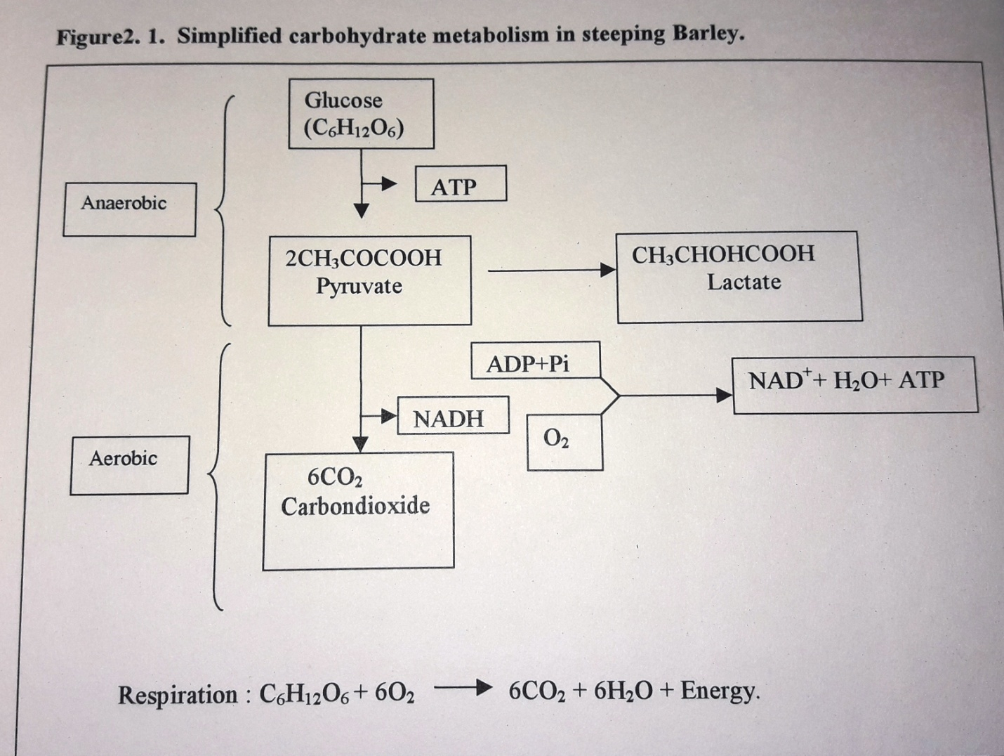

microorganisms. Changes in proanthocyanide levels in different cultivars of Sorghum bicolor, revealed a decrease by 48 to 59% during malting (Bvochora et al, 1999). Addition of potassium permanganate not only sterilizes the steep liquor but also increases the available nascent form of oxygen to the developing grains (Pallas, 1934). Alkali steeping of tannin free sorghum improved the resulting malt quality in terms of diastatic power and free amino nitrogen (Dewar et al, 1997). Effect of acetic acid and sulphr dioxide on barley was reported to reduce the rootlet growth and total malting loss (Spillane and Briggs, 1966). Cantrell et al (1981), also studied the changes in various parameters of the steeping environment viz., oxygen, carbon dioxide, temperature, pH and ethanol levels at various points in conical and flat bottomed vessels during steeping of barley grains.

2.4.2 Germination
The germination process comprises of two phases : radical emergence and seedling growth. The first phase is mainly a result of absorption, while the second one is dependent upon the mobilization of seed reserves (Bewley and Black, 1978). Carbohydrates, proteins and lipids are the major storage reserves of cereals. Van Overbeek (1966), reviewed in detail the role of plant hormones (Figure 2.2) and regulators, in regulating its growth via nucleic acid and enzyme synthesis.
As early as 1926, Kurosawa showed that an extract from the fungus Gibberela fujikuroi caused abnormal growth in rice and other plants, which he named as Gibberlin. Palmer (1974), has extensively reviewed the industrial applications of gibberlic acid. Abscisic acid was found to inhibit the growth of rootlets but it increases the malt yield in combination with gibberlic acid (Yamada, 1983). External application of gibberlic acid is also known to increase proteolysis and starch hydrolysis and decrease the germination time (Floyd M.Ashton, 1976; Michael R.Sfat and James A.Doncheck, 1978). Brookes and Martin (1975), determined quantitatively the amount of gibberlic acid that may be supplemented to the naturally occurring one.
Gibberlic acid is produced by the embryos and is transported to the aleurone layer where a number of hydrolytic enzymes are produced (MaCleod and Miller, 1964; MaCleod et al, 1964). Verner and Ramachandran (1964), used radio active labeling and finger printing methods of the proteins derived from barley endosperm and confirmed that GA₃ induces α−amylase and protease synthesis. The figure 2.3 represents the movement of exogenous and endogenous
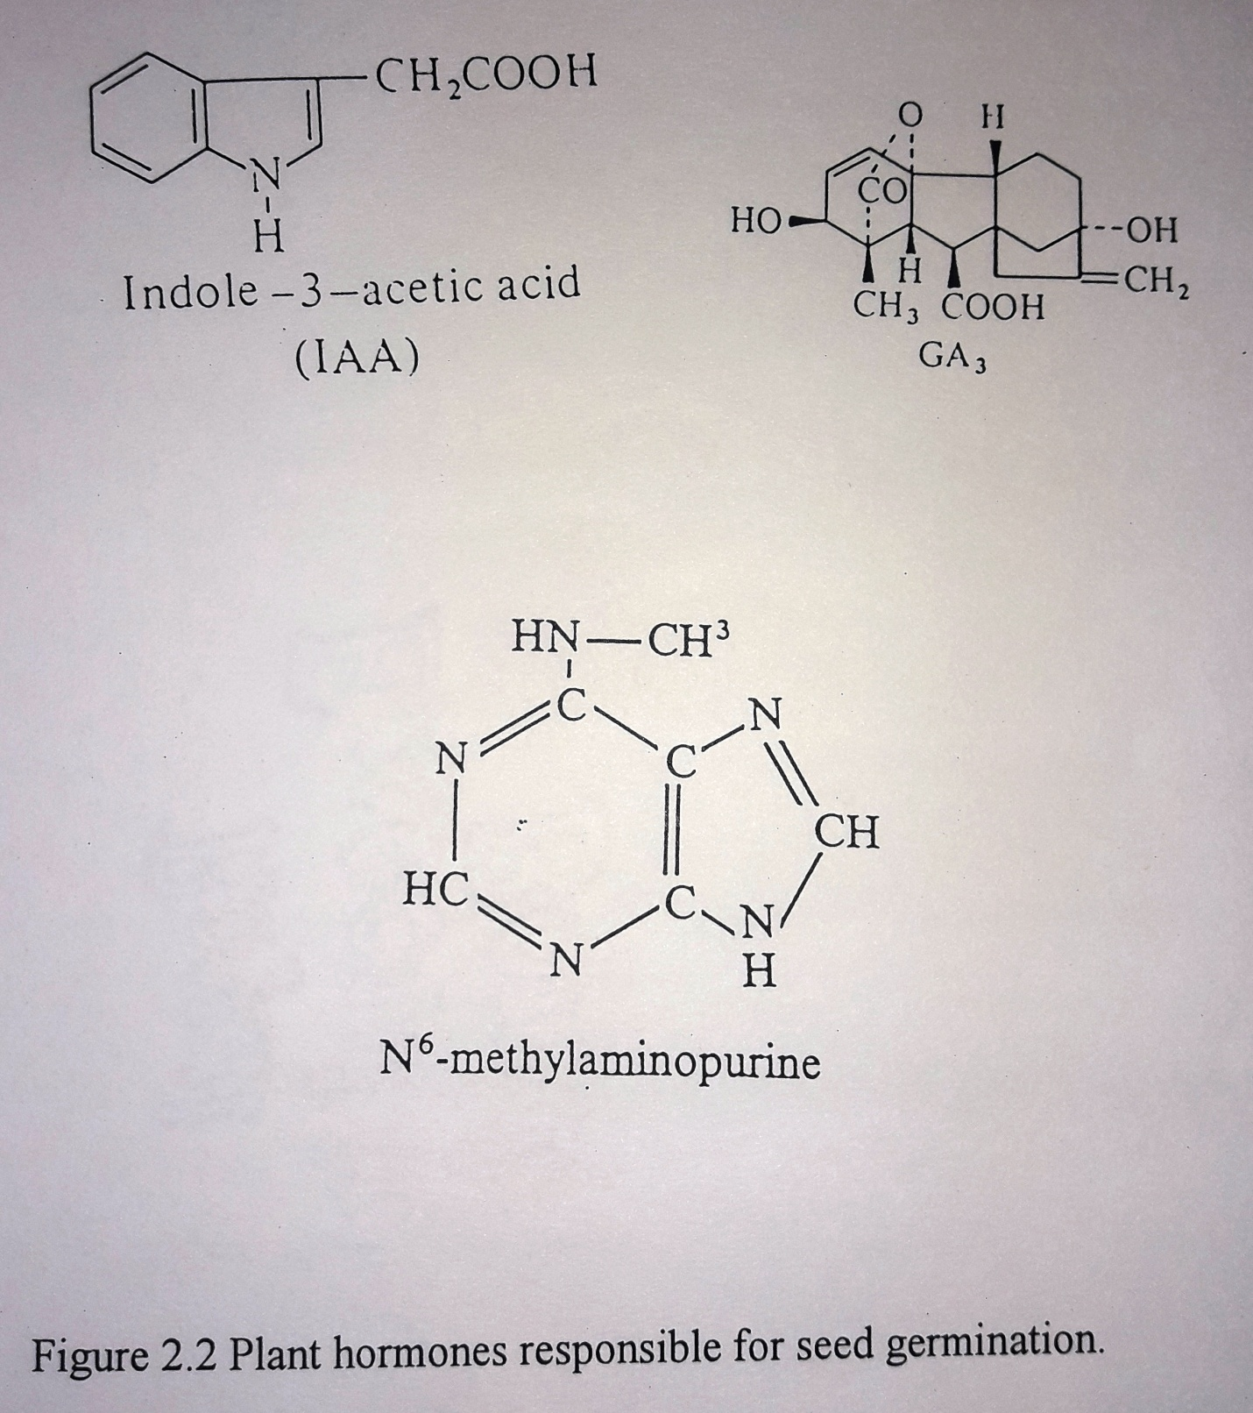

transcription rate and mRNA stability. Gibberlic acid induced changes in the accumulated polypeptides in dwarfs of maize and pea may be due to increased efficiency in translation of certain mRNA’s. Gibberlic acid promoted denovo synthesis of α−amylase (John V.Jacobsen and Thomas J.V.Higgins, 1982; Jacobsen and Beach, 1985), proteases and carboxypeptidases (Rachel W.Hammerton and Tuan-Hua David Ho, 1986), Nucleases (Peter H.Brown and Tuan-Hua David Ho, 1986) and other carbohydrases (Palmer, 1973) in barley have been well documented.

2.4.3 Mobilization of seed reserves
The growing seedling requires energy for its growth and development. These are met by degrading the reserve food material in the endosperm by the development of a number of hydrolytic enzymes (Bewley and Black, 1978). In cereals, the major reserve materials are starch and protein.

2.4.3.1 Mobilization of starch
An increase in the activities of amylases and maltase during germination causes a gradual decrease in the starch content with a parallel increase in reducing and non-reducing sugars in everal cereal grains (Bartlett, 1917; Fukai and Nikumi, 1956; Lemar and Swanson, 1976). α−amylase, β−amylase, endo- β−gluconase and limit dextrinases are the enzymes involved.
Pearl millets are the only cereals reported to contain preformed α−amylase (Hoseney et al, 1981). In sorghum the α−and β−amylases were reported to be higher in the embryo (Dyer and Novellie, 1966), where as in Nigerian sorghum they were reported to be almost same (Aisien et al, 1983). α−and β−amylases were found to be maximum on the 3rd day of germination for sorghum (Uvere Peter et al, 2000). The development of diastatic power of seed varies with the variety chosen, the season, maturity of the seed and also the age of the seed (Novellie, 1962).
Several reports exist on the development of amylases in cereals for application in brewing. Bajra malt was reported to contain lower amylolytic activity when compared to barley (Singh and Tauro, 1977). Asha Pal et al (1976) reported that these two matls had comparable proteolytic as well as amylolytic activities. Malleshi and Desikachar (1986) reported that millets develop α−amylases faster (2-3 days) when compared to tropical cereals. Finger millets, sorghum and barley are reported 6th, 9th and 5th day of germination respectively (Nout and
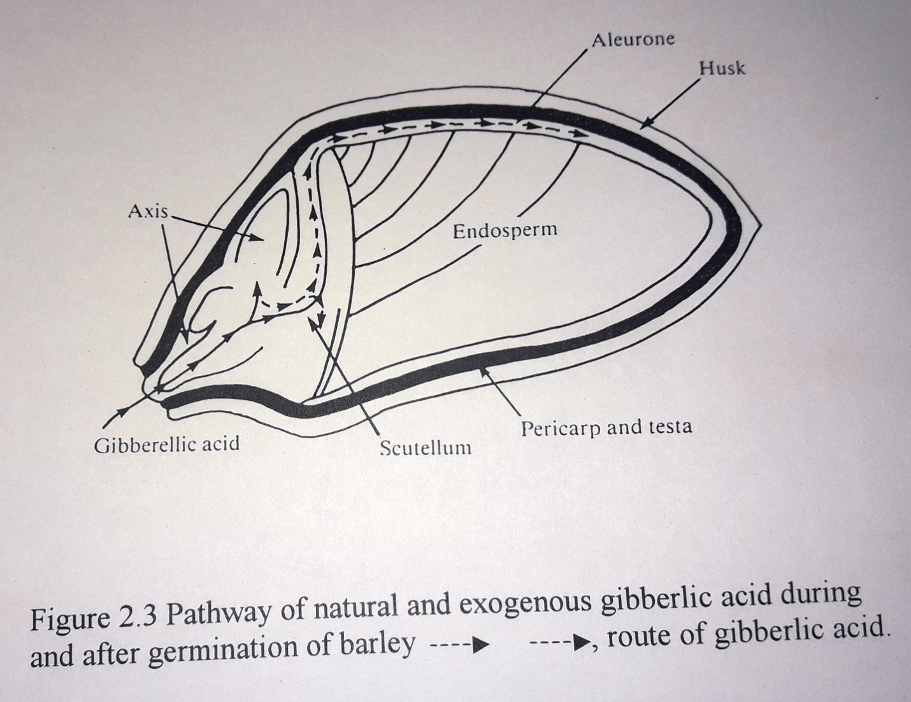

gibberlic acid during germination in barley. Gibberlic acid also increases the number of monoribosomes and the percentage of polyribosomes, which are a prerequisite for the hormonal induction of protein synthesis. Joanne Chory et al (1987) reported gibberlic acid induced changes in the population of translatable mRNA’s and changes in the expression of a subset of gene products within elongating dwarfs of maize and pea. The latter might be due to changes in the
Davies, 1982). Of all the cereals, Barley was reported to contain maximum saccharifying activity (Eric Kneen, 1944).
In barley α−amylase is synthesized in the aleurone layer. The synthesis and transport of amylase and the breal\kdown of endosperm cell wall material were studied using visual methods by Gregory C.Gibbon (1980). In sorghum, scutellar tissue is responsible for α−amylase production (Briggs, 1972). Gibberlic acid usage increased the α−amylase expression and hence the enzyme activity (Atanda and Miflin, 1970).
Effect of germination on the changes in β−amylase activities was monitored with time in wheat (Saharan and Wagle, 1972), sorghum (Novellie, 1960), bajra and barley (Sheorain and Wagle, 1973; Home et al., 1985). In bajra the increase in β−amylase content was rapid during the first 30 hours and then gradually decreased, whereas in wheat it was maximum at 96 or 120 h and in barley it was around 72h.
The other enzymes include limit dextrinases and maltases. Limit dextrinases or the debranching enzymes present in barley and other plants have been very well documented (Kneen and Spoerl, 1984); Hopkisn and Weiner, 1955). These debranching enzymes play a prominent role during mashing α−Glucosidase or maltase in the other important enzyme. It was detected in barley (Clutterbuck and Briggs, 1973), sorghum (Watson and Novellie, 1974), rice (Murata et al, 1979) as well as in other plants (Matsui et al., 1979). This enzyme is mainly responsible for splitting maltose to glucose units, which is metabolized by the growing embro. The effect of temperature on the α−glucosidase preparation of sorghum and barley malt and the effect of pH on its activity were studied by Agu and Palmer (1997). Sorghum malt had maximum α−glucosidase enzyme when prepared at 30ºC. the enzyme activity was highest at pH 3.75 and pH 4.6 for sorghum and barley α−glucosidases, respectively.
The final result of starch mobilization is the decrease in starch content (Pathirana et al, 1983) and increase in free sugar content (Dronzek et al, 1972). Total sugars content was reported to be increased from 1.44% to 8.36% and total carbohydrate was observed to have decreased from 81% TP 58% in finger milletmalt after 96h of germination (Nirmala et al, 2000). Anna M.MacLeod et al (1953), reported the changes in free sugar content in barley for a period of 16 days. Raffinose is metabolized rapidly and completely within 6 days. Glucose and maltose decreased rapidly during steeping when compared to other sugars.

2.4.3.2 Mobilization of proteins
Proteins are mainly in the aleurone layer of the endosperm of monocots (Altschul et al, 1966). The degradation of proteins by proteolytic enzymes of seeds finally leads to free aminoacid formation (Floyd M.Ahston, 1976; Muntz et al, 1985). Albumin and globulin fractions have seen reported to contain endogenous enzymes (Taylor, 1983), which are responsible for protein hydrolysis. The proteolytic enzymes, which are mainly involved in the mobilization of proteins, are exopeptidases, endopeptidases and dipeptidases. Burger et al (1968;1970) characterized three peptide hydrolases of barley, viz., peptide hydrolase A, peptide hydrolase B, peptide hydrolase C amidases and esterases. Baxter (1978), purified carboxypepidases from barley, which will release aminoacids from proteins. In maize endosperm, an acid protease possessing endoprotease activity was characterized by Harvey and Oaks, (1974).
The changes in the different protein fractions of sorghum were studied by Titilayo S.Anibaba et al (1997). Changes in the prolamine content in wheat, triticale, barley, rye and oats indicate its content is found to decrease with time. Prolamines are manly located in and near aleurone cells and form he major source of nitrogen (Dalby and Tsai, 1976). Agu and Palmer (1997), studied the effect of different temperatures i.e., 20ºC, 25ºC and 30ºC on protein break down in he endosperm by enzymes. The aminoacid and peptides transfer from embro to rootlets was less at 30ºC. Enari and Mikola (1977) stated that there is a massive denovo synthesis of the hydrolytic enzymes in malting of barley. Rachel W.Hammerton and Tuan-Hua David Ho (1986), studied the development of protease and carboxpeptidase though synthesized at the time of imbibitions was released only when incubated in GA₃ containing medium, while the proteases activity increased just as in the case of α−amylases. Effect of growth regulators such as cytokinins, Phenyladenine was shown to stimulate proteinases synthesis in the absence of embryonic axis (Donald Penner and Floyd M.Ashton, 1967).
Changes in the amino acid pattern of germinated barley were investigated by Folkes and Yemm (1958). The lysine, tryptophan and methionine content increases with time in corn and sorghum (Wand and Fields, 1978). Wu and Wall (1980) studied the changes in essential aminoacid content of sorghum. Isoleucine, lysine, Threonine, methionine, cytine and valine content slightly increased, lysine initially increased on 2nd day and then decreased whereas phenyl alanine + cystine showed wide variation but finally decreased in content. The comparative amino acid profile of millet and sorghum was reported by Shambe et al (1989), and the pattern of change for various amino acids was found to be almost similar.

2.4.3.3 Mobilization of lipids
Reports exist on the increase in lipid content of germinated grians of barley (Liu and Pomeranz, 1976), wheat (Ranhort et al, 1977) and oats (Bartlett, 1917). Whereas in sorghum (Perisse et al, 1959) and millets (Andy R.Opoku et al, 1983), the lipid content decreased. In case of millets a decrease in lipid content comparable to that of barley is observed after 72h of germination (Harris, 1962).

2.4.3.4 Changes in vitamin content
Thiamine and ascorbic acid content is reported to increase in finger millets, pearl millets and foxtail millets on germination (Malleshi and Desikachar, 1986). Sprouts of wheat are reported to be rich in vitamin B and also contain pro-vitamin A and vitamin D and E (Lemar and Swanson, 1976). Opoku et al (1981) reported a considerable increase in riboflavin, thiamine, ascorbic acid, vitamin A, carotene, tocopherol and niacin in germinated grains.

2.4.3.5 Changes in mineral content
Sankara Rao and Deosthale (1983), reported the loss in mineral content of pearl millets during malting. A reduction in phytin phosphorus in pearl millet and ragi was responsible for the increase in iron and zinc. Decrease in calcium, total phosphorus and phytates and phytate-phosphorus was observed in different millet varieties (Malleshi and Desikachar, 1986). The decrease in the later two components will increase the translocation of the minerals during germination of cereals (Lorenz, 1980).

2.4.3.6 Effect of germination conditions
Dewar et al (1997), studied the effect of time, temperature and moisture on germination of sorghum seeds. The days of malting required decrease with increase in temperature. Luers (1922) reported that the barley malt obtained by germination at higher temperature (73ºF for 6 days) gave Munich beer of a better quality. Pearl millets were grown at 25ºC by Malleshi and Desikachar (1986). Sherain and Wagle (1973) germinated bajra at 35ºC and barley at 25ºC for β−amylases production. Singh and Tauro (1977) germinated bajra and barley at 17ºC to use the malt for brewing purposes, and Berfort and Henriksnas (1983), germinated barley at 13ºC for a period of 6 days.
The optimum temperatures for maximum germination at a faster rate for different cereals were reported by Mayer and Poljakoff Mayber (1963). Wheat, oat and pearl millets were germinated at 15+ 1ºC to study α−amylase activity (Line back and Ponpipom, 1977). Sorghum was germinated at 25ºC for 7 days to monitor the enzyme break down of endosperm proteins (Titilayo S.Anibaba et al, 1977). The effect of different temperatures (20ºC, 25ºC and 30ºC) on the endosperm protein content of sorghum was monitored by Agu and Palmer (1996). Peptides transfer from endoperm to embryo was observed to be faster in barley than in sorghum when germinated at their optimal temperatures of growth , i.e., 30ºC and 17ºC respectively (Agu and Palmer, 2000).

2.5 Kilning
The purpose of kilning is to arrest the biochemical activity within the seeds. By reducing the moisture content to about 4-5%, both biologically and microbiologically stable malt can be obtained and stored. Malleshi and Desikachar (1986) exposed finger millet seed sprouts to different temperatures to get malt with a characteristic aroma and the seeds were roasted upto 70ºC. Nout and Davies (1982), exposed sprouts of finger millets, sorghum and barley to 50ºC and at 20mm Hg for 12ºC to use the malt for lager beer production. After kilning the seeds were stored at 3ºC. Yo study the comparative malting characteristics of some selected cereals, Maleeshi and Desikachar (1986), dried the seeds at 45ºC and roasted at 70ºC to get desired flavor. Bertoft and Henriksnas (1983), kilned barley sprouts for 21 h at 55ºC and used the malt as amylase source. Drying sorghum at 60ºC resulted in loss of β−amylase and partial loss of endo-(1,3)(1,4)- β−D- glucanase activities, but the α−amylase was found unaffected upto 5h of kilning (Uriyo and Ergel, 2000). Agu and Palmer (1996), kilned barley and sorghum at 50ºC for 16h and Titilayo S.Anibaba et al (1997), kilned sorghum at 55ºC for 24h to study the changes in protein content of seeds. Sorghum was kilned at 50ºC for 24h to use the malt for brewing purpose (Dewar et al, 1997).

2.6 Mashing
The mashing process involved incubation at optimal temperatures of the milled malt with the cooked adjuncts in aqueous suspension in order to solubilise the components of the malt and the adjuncts both physically and enzymatically to produce fermentable wort. The variables, which affect the saccharification process, are temperature, time, malt:adjunct ratio and pH. The enzymes involved in mashing are α− amylase, β−amylase, proteases and β−glucanases. Zherebtsov et al (1983), reported that treatment of grains with heteroauxins, enhance the enzyme activity and thus the saccharification activity of millet malt. Leo J.Dengult et al (1981), studied the effect of α−amylase, β−amylase and β−glucanase on malt barley and flour of rice and corn during mashing process. They used a modified infusion-mashing schedule. A general infusion-mashing schedule comprises of proteolytic hold for 30 minutes at 45ºC, sacchrification stand for 30 minutes at 65ºC and mashing off for 30 minutes at 76ºC. temperature rise between stands was 2ºC/minute (Figure 2.4).

2.6.1 Adjuncts
An adjunct is defined as any material, which can be used in place of fully, kilned malt during the production of alcohol with or without the addition of enzymes (Satyanarayana Rao and Narasimham, 1975). Raw barley, wheat, rye and triticale grains can be directly used as adjuncts without prior cooking (Koszyk and Lewis, 1977; Lloyd, 1978; Martin , 1978 and Canales, 1979). Shah and Joshi (1999) studied the effect of Quercus wood chips on the quality of peach brandy.
The cereal grains used in opaque breqing , i.e., maize, sorghum and millets have to be cooked seperatley and have a high gelatinization temperatures in the range of 62ºC- 75ºC (Briggs et al, 1981). Cooking of the grain disrupts its internal structure. Table 2.6 lists the various adjuncts that can be used for brewing purposes. These yield a good extract during mashing. Haggblade and Holzapfel (1989), listed millets as sources of starch for brewing purposes.
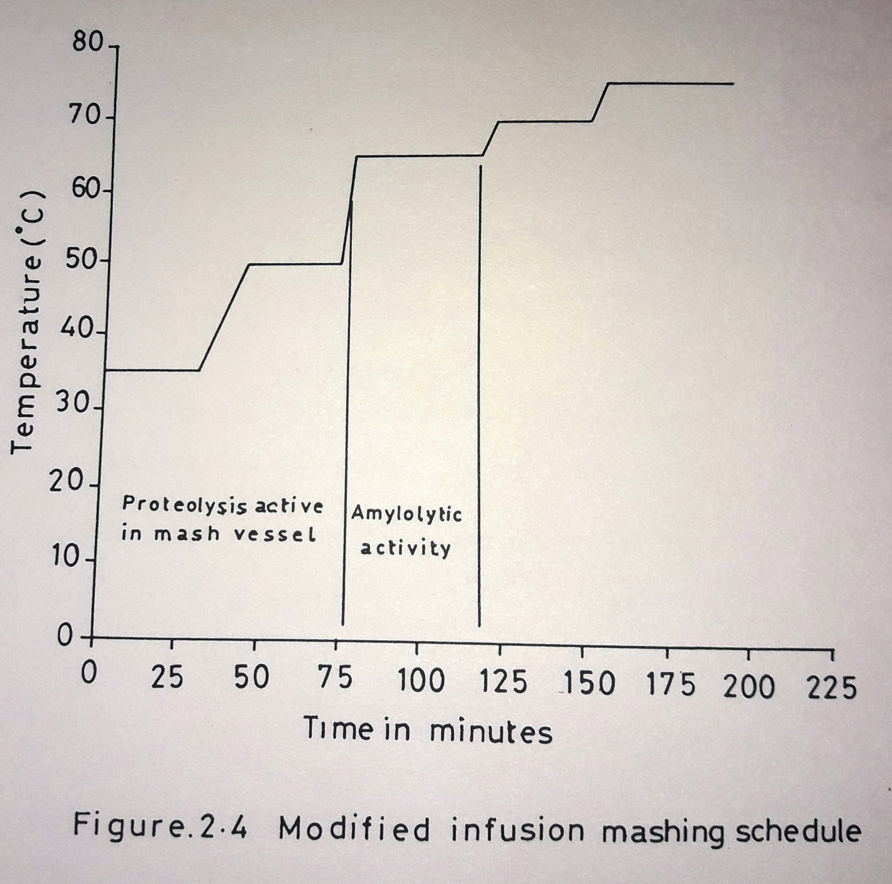

Table 2.6. Analysis (ASBC) of various adjuncts
 | Moisture  % , as is | Extract % |  | Protein  % as is | Fat/Oil  % as is | Fibre%as is | Ash % as is | pH | Gelat*
 |  | As is | On dry |  |  |  |  |  | (ºC) | (ºF)
Maize (Corn grits) | 11.6; 11.9 | 79.3; 80 | 90 | 8.5; 9.2 | 0.8 | 0.7 | 0.3 | 5.8 | 61.5 – 73.9 | 143 – 165
Rice grits | 11.0; 12.2 | 81.7; 82.1 | 92.7 | 5.4; 7.5 | 0.2; 0.6 | 0.6 | 0.8 | 6.4 | 61.1-77.8 | 142-172
Sorghum grits | 10.8 | 81.3 | 91.1 | 8.7 | 0.5 | 0.8 | 0.3 | - | - | -
Refined maize starch | 11.0 | 92.9 | 103.1 | 0.4 | 0.04 | - | - | 5.0 | 61.5-73.5 | 143-165
Refined wheat starch | 11.4 | 95.2 | 105.2 | 0.2 | 0.4 | - | - | 5.7 | 51.5-63.9 | 125-147
Terrified wheat | 4.9 | 74.4 | 78.2 | 12.2 | 1.0 | - | - | 6.2 | - | -
Terrified barley | 6.0 | 67.9 | 72.2 | 13.5 | 1.5 | - | - | 5.9 | - | -

Source: Briggs et al, 1981.
Gelat*., Gelatinization temperature range

Hayward (1941), reported the usage of Soya bean flakes as adjuncts. Grits consists of uncooked starch derived from cereal grain and contain low lipid content when compared to the grain. Maize grits are widely used in USA as adjuncts (Canales, 1979).
The percentage of adjuncts is also a key factor. A 25% wheat flout as adjuncts was used by Birtwistle et al (1962). Maule and Green Shields, 1970, listed the percentages of grits of barley and wheat, which may be used with different malts, that were used as enzyme sources by various authors.

2.6.2 Hops
Hops are employed in the brewing process to impart bitterness to beer. They also provide vide hop aroma and flavor or hop character. The beer bittering substances derived from hops arise predominantly from the α−and β−acids, also known as humulones and lupulones (Verzele, 1979). Hops used in brewing industries are the dried blossoms of the female hop plant (Humulus lupulus). The chemical composition of hops is listed in table 2.7.
The usage of hop extract instead of the direct hops and isomerized hop extracts (Hudson, 1979) is done mainly to get consistent bitterness. This also improved stability and allows long term storage of hops.

2.6.3 Enzyme source
Barley malt is used in many traditional starch hydrolysis as it contains a high diastiatic activity (Hudson, 1972). Sorghum malts are used in Kaffir beer brewing (Novellie, 1966). Nout (1980a) used solely finger millet malt in the preparation of busaa, a Kenyan opaque beer from maize.
Ethanol from uncooked starch hydrolyzed using fungal enzyme preparations were reported (ueda and Koba, 1980 and Ueda et al, 1981). The enzyme used was glucoamylase from Aspergillus niger and Aspergillus awamori. Similar type of enzyme preparations were used but the organism used for enzyme source was different, viz ., Rhizopus sp (Matsumoto et al, 1991). Chalara rolfsii AHU 9627 (Jimmy Hariantono et al, 1991) and Chalara paradosa (Mikuni et al, 1987). Aspergillus awamori was directly employed for sacchrification by coimmobilizing the organism with Zymomonas mobilis for ethanol production (Hideo Tanaka et al, 1986).

Table 2.7 Chemical composition of hops
Component | Percentage
α- acids | 2 – 12
β- acids | 2 – 10
Essential oils | 0.5 – 1
Polyphenols | 2 – 4
Oil and fatty acids | Traces to 5
Wax and steroids | Traces
Protein | 15
Cellulose | 40 – 50
Water | 8 – 12
Chlorophyll | Traces
Pectins | 2
Ash | 10

Sources: Verzele, 1979.

Addition of starch debranching enzymes such as isoamylases , amyloglucosidase or pullulanase increased the fermentable sugar content of wort (Willox et al, 1977). The application of β−amylase in the production of reducing dextrin beer was reported by Norris and Lewis (1985).

2.7 Effect of physical parameters on mashing
The physical parameters have a role to play in the final yield of reducing sugars and these are as follows.

2.7.1 Malt/grain ratio
This is dependent upon the diastatic power of the malt. Sorghum has a lower diastatic activity and hence the ratio was kept between 1:3 and 1:2 (Novellie, 1966). According to Taylor (1989), the ratio was used in the industrial brewing of sorghum in South Africa was 1:4. In the preparation of traditional rice drink in Korea, Ann Yong-Geun (1999) used 4% malt and 20% rice during mashing.

2.7.2 Malt
The diastatic power of malt is mainly due to the presence of α−amylase, proteases and minor amount of β−amylase. Malleshi and Desic\kachar (1986), reported the changes in the content of α−amylase, starch and free sugars of few tropical cereals and millets (Table 2.8).
Eric Kneen (1944) too studied the development of amylases in few germinating cereals and concluded that malts of barley, wheat and rye have both α−amylase and β−amylase. Sheorain and Wagle (1973) studied the changes in β−amylase content of bajra and barley and reported that 30h and 70h malting yield sufficient enzyme for further usage. The diastatic unit of malt determines the malt/adjunct ratio to be used during mashing. In the preparation of Sikhye the malt used had 9,725 units enzyme activity per gram of malt (Ann, Young-Geun, 1999).

2.7.3 Effect of pH, temperature and time of mashing
Novellie (1966), has done a comparative study on the effect of the selected parameters on sugar production from adjuncts using sorghum malt. A pH of 6.3 and a temperature of 60ºC were reported to be optimum for maximum starch hydrolysis. In the case of brewing processes involving souring, pH drops down to the range 3.8 to 4.0. This destroys α−amylase (Taylor,
Table 2.8. Changes in the α-amylase activity, starch and free sugar content of few tropical cereals and millets
Sample | Ungerminated samples |  |  | 48h germinated sample |  |  | 96h germinated sample
 | α−amylase activity * | Starch ! | Free sugar ! | α−amylase activity * | Starch ! | Free sugar ! | α−amylase activity * | Starch ! | Free sugar !
Rice | - | 77.9 | 1.2 | 50 | 74.6 | 3.1 | 105 | 70.8 | 5.4
Wheat | 2.0 | 71.0 | 2.3 | 120 | 67.1 | 3.8 | 230 | 59.6 | 8.7
Maize | - | 66.3 | 1.3 | 50 | 63.2 | 3.0 | 150 | 59.8 | 5.9
Sorghum | 0.5 | 68.7 | 1.7 | 67 | 64.5 | 3.4 | 170 | 58.9 | 6.3
Triticale | 2.5 | 70.4 | 2.6 | 145 | 65.1 | 4.4 | 260 | 57.4 | 8.5
Finger millets | 4.0 | 65.5 | 1.1 | 165 | 58.9 | 3.3 | 200 | 53.6 | 5.9
Pearl millets | 4.6 | 69.0 | 1.4 | 170 | 61.4 | 4.1 | 154 | 57.5 | 7.3
Proso millets | 1.0 | 60.5 | 1.8 | 100 | 57.5 | 3.8 | 145 | 53.0 | 5.0
Foxtail millets | - | 60.3 | 1.3 | 85 | 56.0 | 2.6 | 132 | 52.6 | 4.9
Barnyard millets | - | 57.0 | 1.0 | 48 | 56.1 | 2.9 | 70 | 52.0 | 3.7
Kodo millets | - | 54.9 | 1.2 | 10 | 52.9 | 2.8 | 55 | 50.7 | 3.9

Source: Malleshi and Desikachar (1986)
* mg of maltose released by the action of malt enzymes extracted from one gram malt in acetate buffer (pH 4.8) on soluble starch at 37ºC
! gm per 100grams of devegetated malt.

1989) and retards the enzyme activity. Wheat β−amylases exert maximum activity in the pH range of 4.9 to 5.3 at 40ºC and α−amylase exerts optimal activity in the pH range 4.6 to 6.3. barley α−amylase has two pH optima (Bines, 1956). The optimum pH and temperature ranges for pure α−amylase were reported to be 4.0 to 5.0 and 45ºC to 55ºC respectively (Abdul-Hussain, 1982).
The optimum temperature and pH for sorghum malt proteinases and carboxypeptidase enzyme are 45ºC and pH 4.25 to 4.50 and pH 4.0 to 5.25 respectively (Evans and Taylor, 1990a). Ann, Yong-Geun (1999), mashed at 60ºC for 5h at pH 5.5 to obtain desirable sugars for fermentations.

2.8 Mashing methods
Mashing methods are of two types, a) decoction mashing method and b) infusion mashing method. Decoction mashing method involved multiple mashing systems and is used for lager beer production. This method involves hydrolysis of the starch present in the malt using its enzymes (Griffin, 1966). In an infusion mashing method containing adjuncts, the mashing program involves exposing the mash to different temperatures for certain period of time. Mashing starts at 35ºC for souring as in figure 2.5 fir a holding periods of 30 minutes, then raising the temperature over a period of 15 minutes, at 1ºC/min to 50ºC and then leave it for 30 minutes for proteolysis. The temperature is again raised to 65ºC and held for 30 minutes, again raised and kept at 70ºC for 30 minutes for amylolysis and finally raised to 75ºC and kept for 30 minutes (Various,, 1974; Narziss, 1976; Botton and Palmer, 1974). Button and Palmer (1974) reported an increase in maltose content when the usual infusion mashing process of 3h was extended by 1 hour thus using a total four hours mashing period.

2.9 Biochemistry of mashing
Mashing mainly involves the hydrolysis of starch (saccharification) and protein (proteolysis). Paul R.Glenister (1976) observed the changes in the spent grains during mashing using staining techniques.

2.9.1 Sacchrification of starch
Amylases are the enzymes, which catalyze starch hydrolysis. Two important amylases are recognized namely, the dextrinogenic, liquefying or α−amylases are recognized namely, the dextrinogenic, liquefying or α−amylases and the saccharogenic or β−amylase. John G.Scandalios et al (1978), listed the criteria for identifying these enzymes in maize (Table 2.9).

2.9.2 Starch
Starch is the second abundant carbohydrate on the planet next to cellulose. The size and shape of the granules vary with species (Manners, 1985). These granules contain 15-30% amylase and 70-85% amylopectin. Amylase is composed of linear chains of α−D glucopyranose linked by α−(1 -> 4) linkages. A very low degree of debranching with some α−(1 -> 6) – D – glucosidic inter chain linkage was reported by Peat et al (1952). Whereas, Amylopectin is a macromolecule containing thousands of short branched chains of D-glucose linked by α−(1-> 4) bonds (Figure 2.6).

2.9.3 Mechanism of starch hydrolysis
During the process of starch degradation α−amylases play most important role (Bertoft and Henriksnas, 1983). Sorghum malts β−amylase is reported to contribute 18-39% of the total sacchrifying activity (Botes et al, 1967). It is believed that α−amylase, which is an ennohydrolase, catalyses the initial steps of hydrolysis of both amylase and amylopectin by cleaving α−(1 -> 4) linkage and results in linear or branched dextrins (Green Wood and Milne, 1968), β−amylases, limit dextrinases and α−glucosidase cause further hydrolysis of these dextrins (Dunn, 1974). The result of the action of α−and β−amylases is the formation of α−and β−limit dextrins which contain α−(1 -> 6) branched points. Limit dextrins hydrolyse the α−(1-> 6) branched points. Limit dextrins hydrolyse these α−(1 -> 6) – D- glucosidic linkages (Manners, 1974). α−glucosidase catalyses the step wise hydrolysis of dextrins from non-reducing ends. The limit dextrinases and α−glucosidase content in comparatively very less and their chances of denaturation during kilning are very high. Figure 2.7 represents the pattern of action of the malt enzymes on the solubilized adjunct starch and the starch present in the malt.

Table 2.9: Criteria used for identifying α-amylase and β−amylases
Criteria | Methods | α-amylase | β-amylase
Action Pattern! | Chromatography of enzyme digest of starch | G₁ + G₂ + G₃ + maltodextrins | G₁ + G₂ + β-limit dextrins
Optical rotation of end products | Polarimetric technique | Decrease of OR towards EQ | Increase of OR towards EQ
Limits of enzymic action | 1) β- limit dextrin prepared from starch digested by sweet potato β-amylase.  2) λ max of limit dextrins- iodine complex absorbance | Further degradation  620 to 500mμ, no apparent λ max | No further degradation  620nm (blue)
pH sensitivity | Enzyme activity at pH 3.5 vs. that at pH 6.8 | Loss of activity upto 90% in 30 minutes | Loss of activity upto 15% in 30 minutes
Thermal stability | Enzyme incubated at 70ºC vs. at 23ºC | Slight loss of activity upto 20% of initial activity | Loss of activity upto 75% of initial activity.

! predominant end products are underlined
G_{o} – n units of glucose

Source: John G. Scandalios et al (1978)

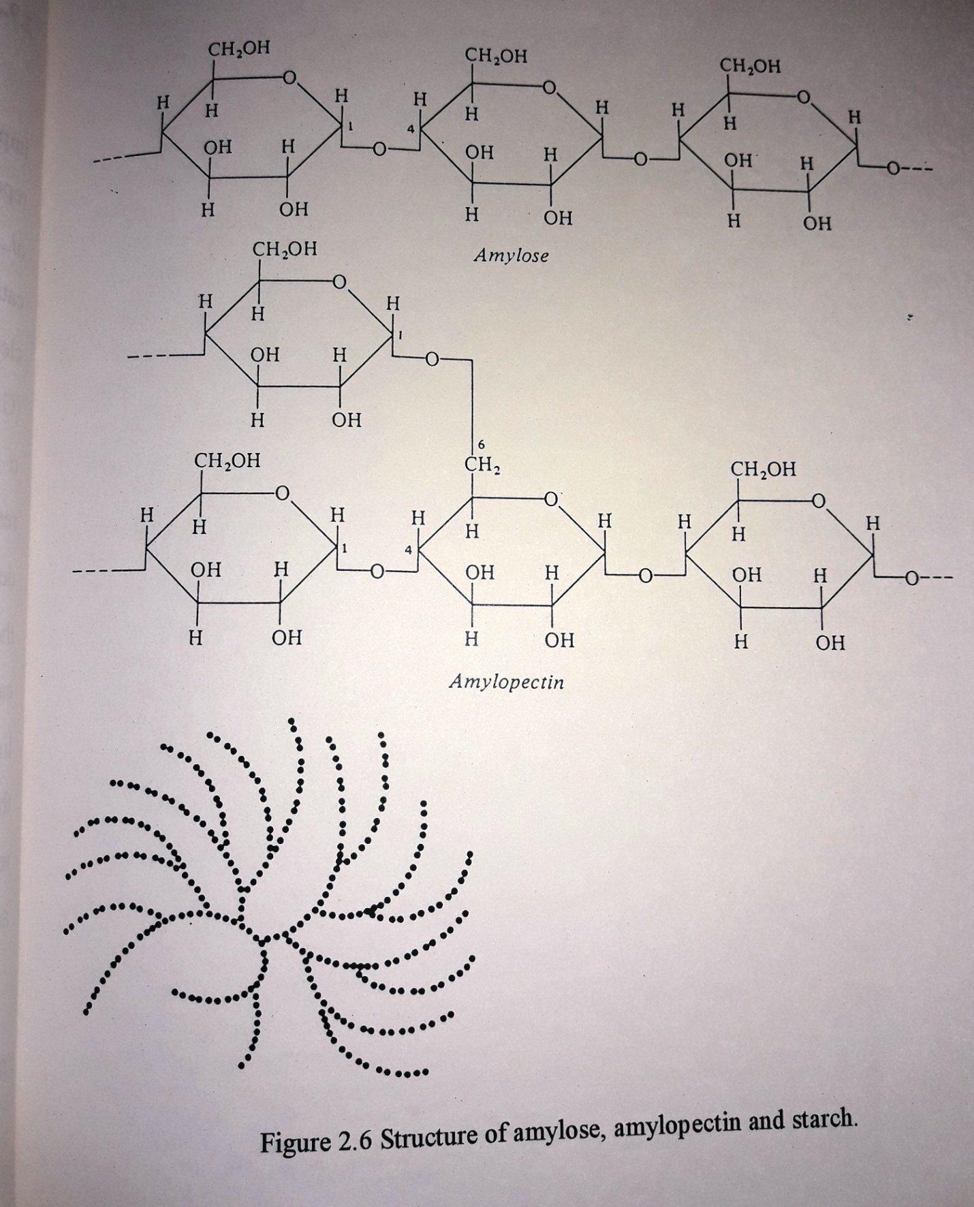
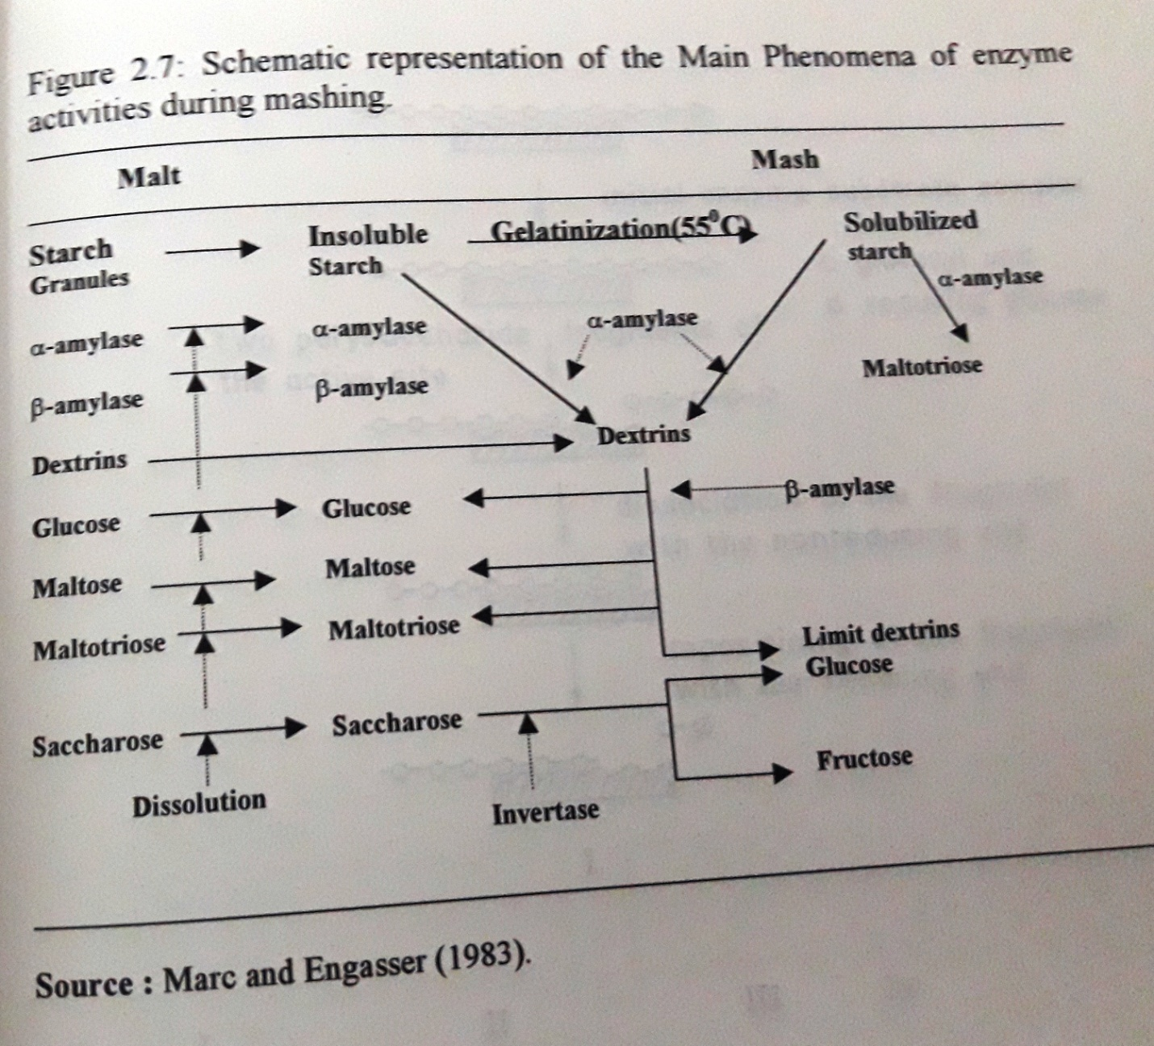

Abdul-Hussain and Varriano-Marston (1982), studied the effect of pearl millet α−amylase on its starch. Amylase was hydrolyzed completely and only some portions of amylopectin were hydrolyzed. Bathgate et al (1973), reported that the small starch granules in barley remained ungelatinized at normal infusion mashing temperatures (60-65ºC) and hence unattacked by amylases. They have a high gelatinization temperature range (51-92ºC). Models for the action of α−amylase on amylase have been proposed by Ann Mac Gregor et al (1994), Elizabeth A.Mac Gregor(1984) and Alex W.Mac Gregor (1985). Figure 2.8 explains the mechanism of action of α−amylase as reported by Robyt (1984).

2.9.4 Proteolysis during mashing
Proteolysis during mashing results in the formation of free α−amino nitrogen (FAN). Cereal adjuncts contribute very little to the final FAN content of the wort (Jones and Pierce, 1964). Table 2.10 lists out the changes in the amino acid content during infusion mashing of barley at 65ºC. The formation of soluble nitrogenous substrates in mashing is due to the comparatively heat stable endopeptidases acting in conjugation with heat sable carboxypeptisases (Milkola et al, 1972; Burger and Schroeder, 1976). The FAN formation in sorghum beer mashing directly depends on the sorghum malt to adjunct ration (John R.N.Taylor and Heather K.Boyd, 1986). Wort FAN is directly proportional to malt FAN.

2.10 Filtration of wort
When the mashing process is completed, the mash may be filtered using filer cloth (Griffin, 1966). In Industrial Brewing in South Africa solid bowl centrifuges (decanters) are used to strain the mash (Novellie and De Schaepdrojver, 1986).

2.11 Composition of wort
The carbohydrate and the nitrogenous substances composition of barley, wheat and maize wort was studied by Maule and Green Shield (1970). Mac William (1968 and 1971), have extensively reviewed the composition of wort. The wort consists of simple sugars, dextrins, amino acids, peptides, proteins, vitamins, ions, nucleic acids and other constituents, which are too numerous to mention.

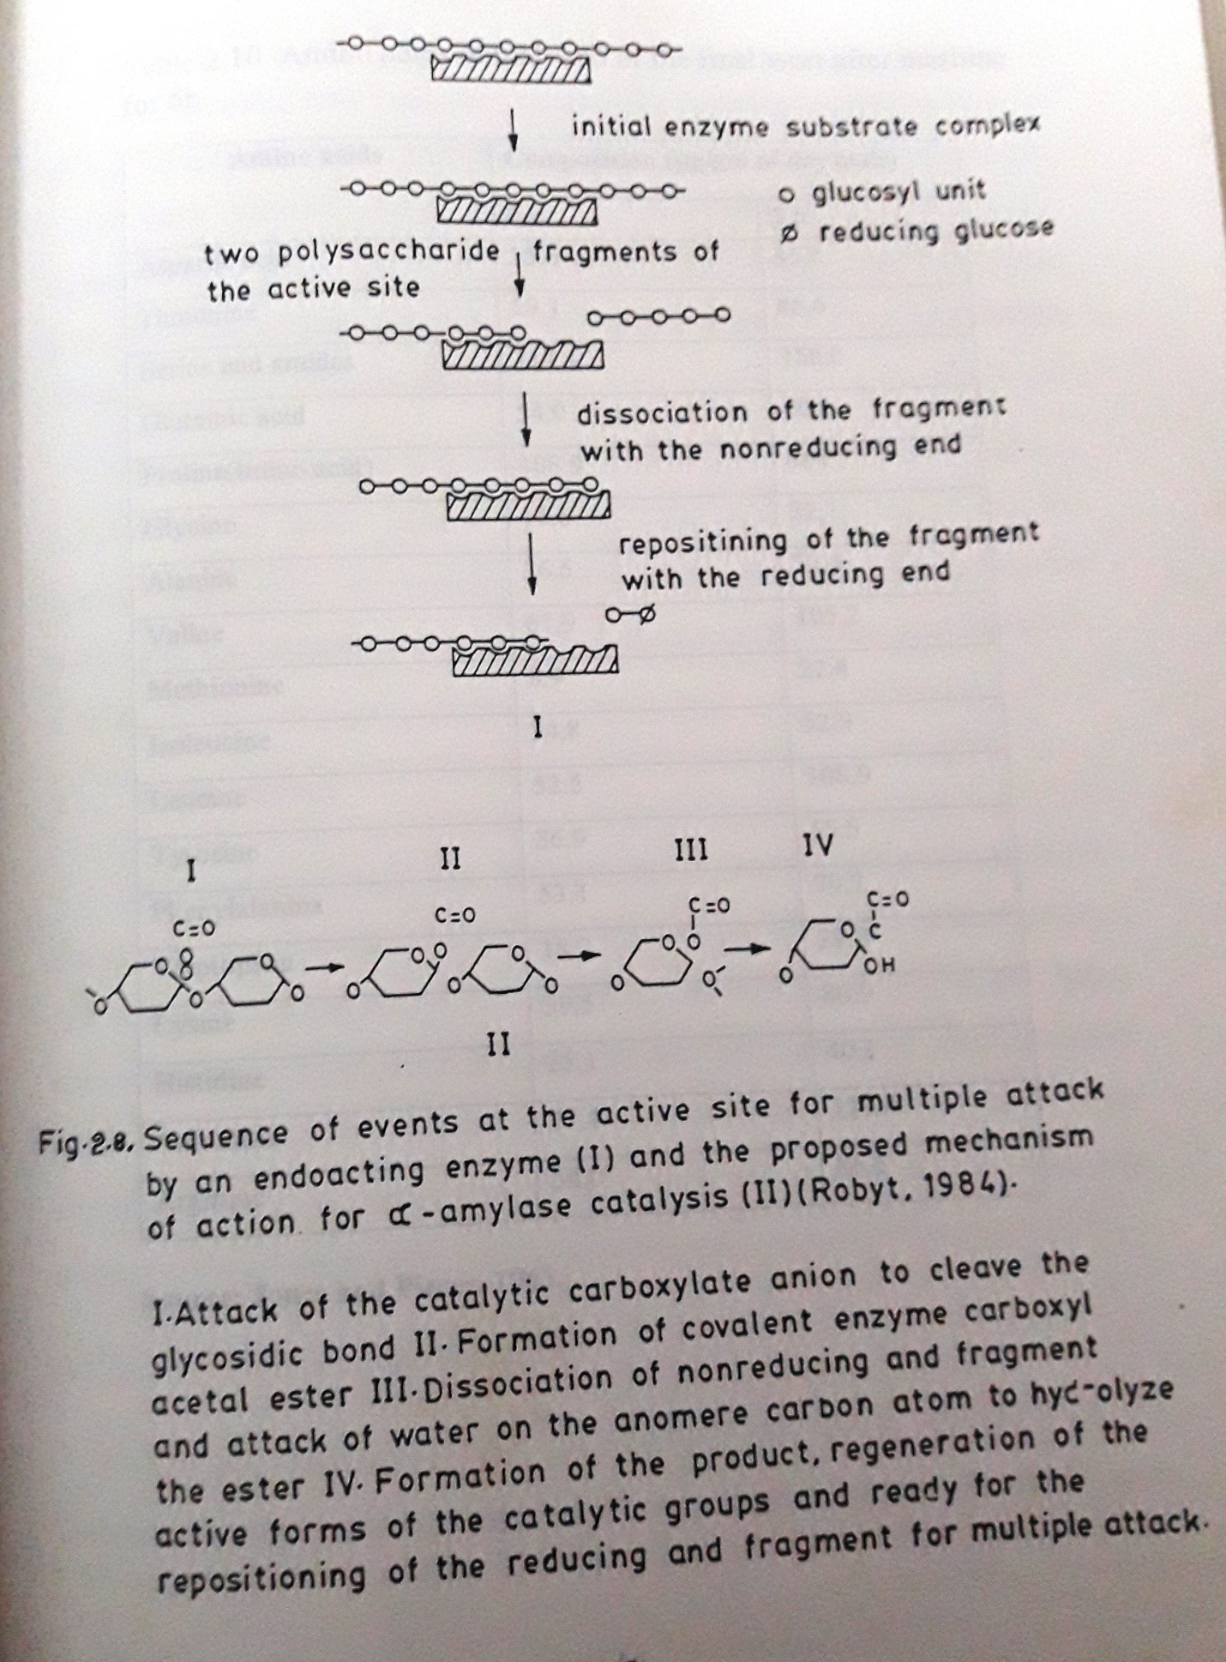
Table 2.10 Amino acids of malt and of the final wort after mashing for 5h
Amino acids | Composition (μg/gm of dry weight)
 | 0h | 5h
Aspartic acid | 35.6 | 45.6
Threonine | 29.1 | 46.6
Serine and amides | 114.4 | 158
Glutamic acid | 54 | 60.6
Proline (imino acid) | 408.9 | 468.7
Glycine | 15.6 | 32.1
Alanine | 36.5 | 72.4
Valine | 61.9 | 105.2
Methionine | 8.9 | 22.4
Isoleucine | 34.8 | 52.9
Leucine | 52.5 | 108.9
Tyrosine | 36.9 | 55.5
Phenylalanine | 53.1 | 79.7
Tryptophan | 18.7 | 29.8
Lysine | 39.5 | 86.9
Histidine | 25.1 | 40.1
Ammonia | 77.4 | 119.4
Arginine | 54 | 86.5

Source: Jones and Pierce, 1963

The sugars present in the wort are glucose, sucrose, fructose, maltose, maltotriose and other dextrin materials. On dry basis, wort contains approximately 60% fermentable sugars, 25% dextrins, 10% gelatinized starch and the remainder is mainly protein (Klaus H.Daiber and John R.N Taylor, 1995).

2.12 Fermentation
Fermentation may be defined as a micro organically mediated enzymatic transformation of organic substances, especially carbohydrates, into useful products generally accompanied by the evolution of a gas. Many microorganisms have been studied for the production of ethanol under aerobic and anaerobic conditions. In ethanol fermentation yeast is the common biological agent used which turns the sugars of the wort into alcohol and carbondioxide.

2.12.1 The microorganisms
Ethanol production can be carried out using bacteria as the fermentative agent. Zymomonas mobilis was used by many workers (Rogers et al, 1984; Gunasekaran et al, 1986; Spanglee and Ernet, 1986; Tonomura and Yanase, 1987; Nain and Rana, 1987; Jain and Nath, 1987; Osman and Ingram, 1987). But the drawbacks in using this organism include its inability to utilize the broad spectrum if substrates and it requires a completely sterile environment. The other bacteria used include Clostridium thermosulfurogenes (Hyun, 1986), C.thermohydrosulfuricum (Staff abd Humphery, 1986, Parkkinen, 1986), C.themocelum (Venkateswaran and Demain , 1986; Gordon et al, 1978), C.thermosaccharolyticum (Shirai and Yorifugi, 1986; Imamshi et al, 1985), Ervinia amylovorans (Bauchop and Dawes, 1959, Dawes, 1963) and Sarcinia sp (Bauchop and Dawes, 1959; Dawes, 1963).
There are many other microorganisms, which have been used for ethanol production. The different organisms including bacteria use don various substrates for the production of ethanol are listed in table 2.11.

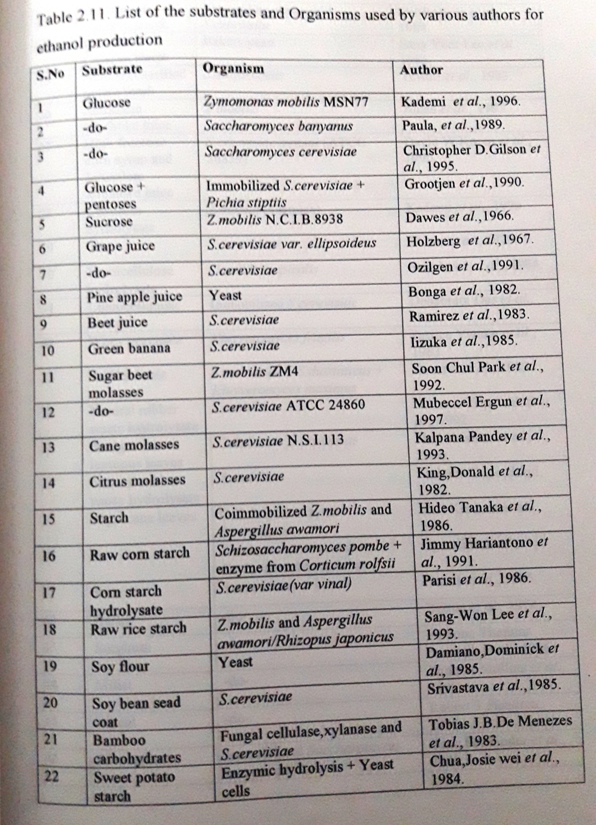
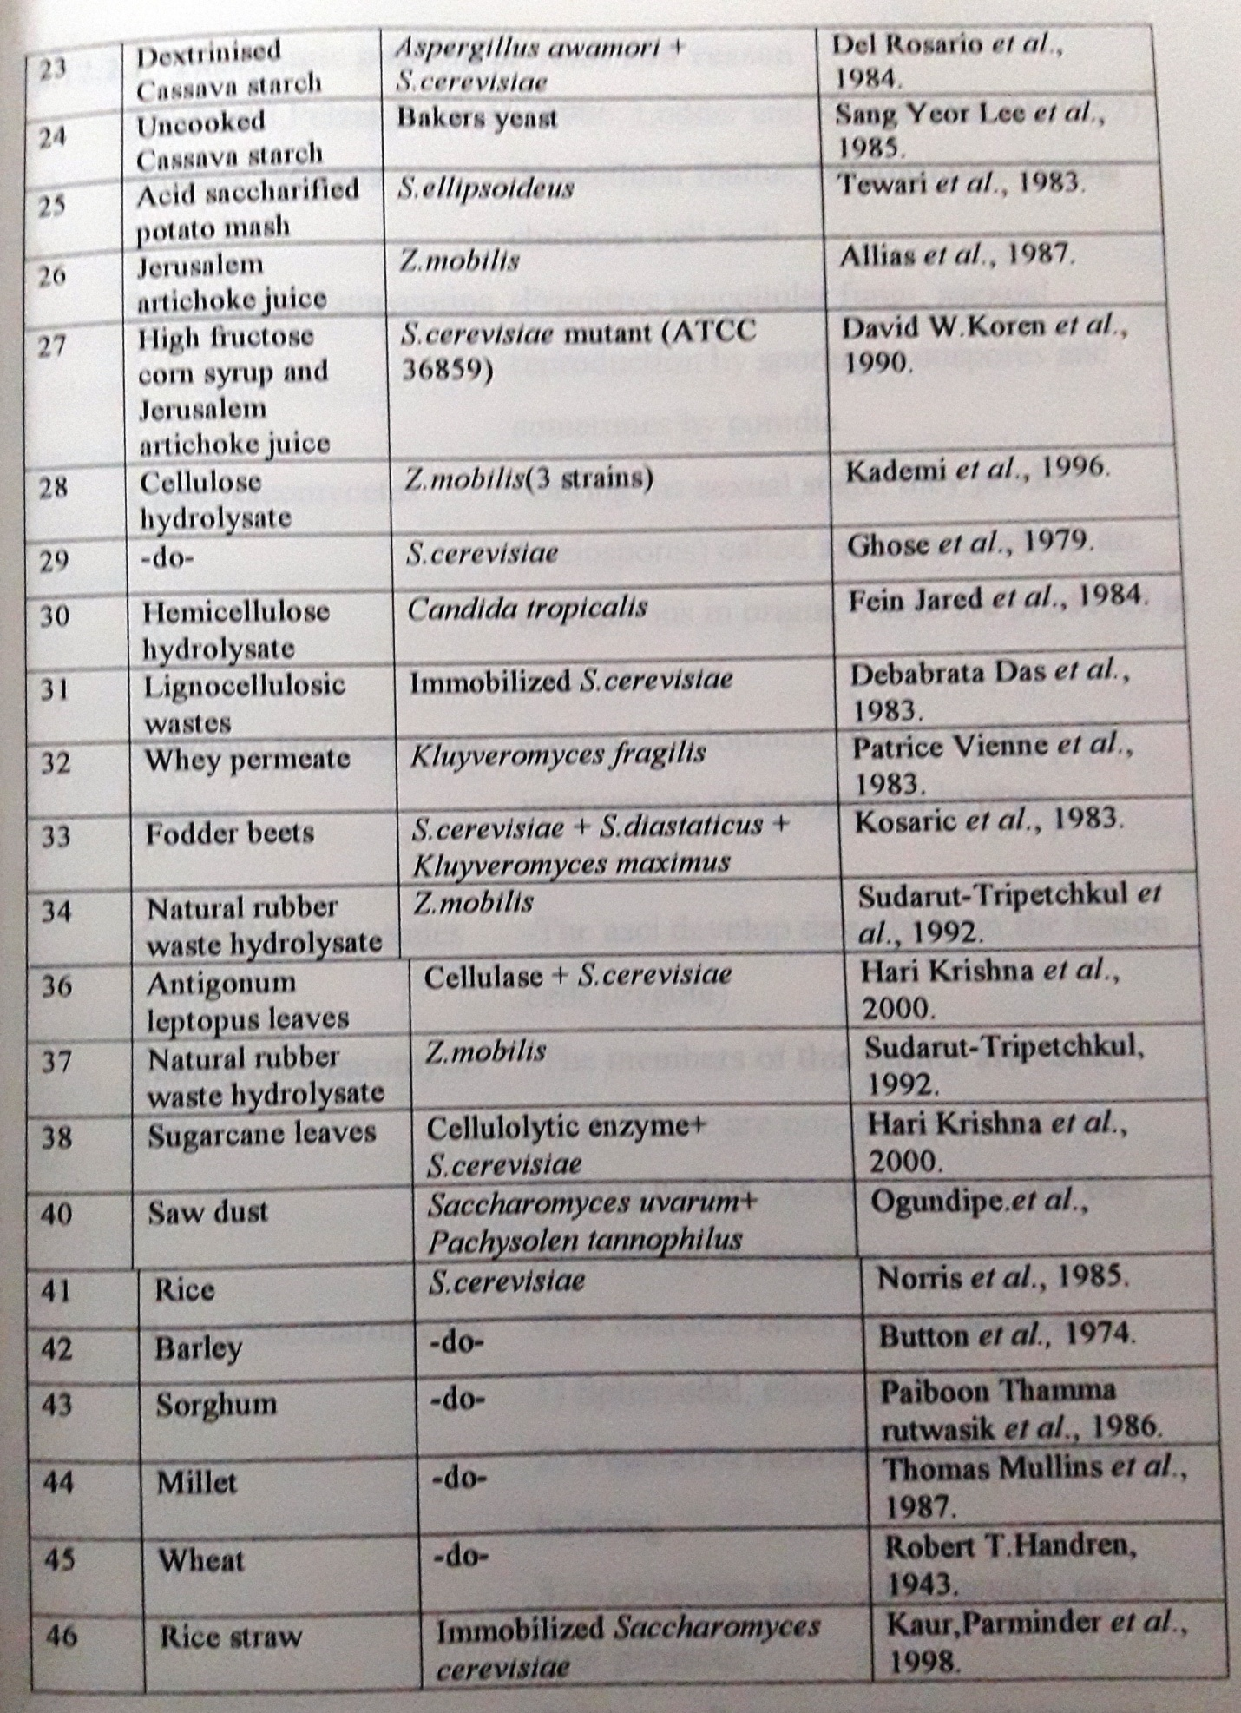
2.12.2 Yeast Biology
The Dutchman, Antonie Van Leeuwen hoek, made the first microscopic observation of yest cells in 1680. In 1837, Cagniard-La tour classified the organism as a member of plant kingdom. Louis Pasteur established the proof of the cellular process of fermentation by 1860. Many scientists worked on yeast taxonomy and finally found it close to fungi. Hence it is placed under the division Mycota. About 39 genera of yeasts were recognized which comprise around 350 species.
2.12.2.1 Taxonomic position of yeast and reason
(Michael J.Pelzar,Jr, et al., 1986; Lodder and Kreger-Van Rij, 1952)
Division Mycota | Unicellular thallus, heterotrophic having chitinous cell wall
Subdivision- Eumycotina | Primitive unicellular fungi, asexual reproduction by sporangia, oospores and sometimes by conidia
Class Ascomycetes | Primitive unicellular fungi, asexual reproduction by sporangia oospores and sometimes by conidia
Subclass – Hemiascomycetideae | Direct developmet of asci without the intervention of acsogenous hyphae
Order- Endomycetales | The asci develp directly from the fusion cells (zygote)
Family- Saccharomyceteae | The members of this family are called yeast. these are non-mycelial with no fruiting bodies. Ascus is naked and they have ability to ferment sugars
Genus- Saccharomyces | The characteristics of this genus are  1) Spheroidal, ellipsoidal or elongated cells  2) Vegetative reproduction by multilateral budding  3) Ascospores sheroidal, usually one to four perascus  4) Most cells cannot utilize nitrates and  5) Most members of the genus grow optimally at pH 4.0 – 6.0 and temperatures of 20ºC – 30ºC.

The electron microscopic structure of yeast is shown in figure 2.9 and figure 2.10 represents the life cycle of Saccharomyces cerevisiae. The cell volume of the budding yeast of Saccharomyces cerevisiae was found to increase as an exponential function of its growth rate
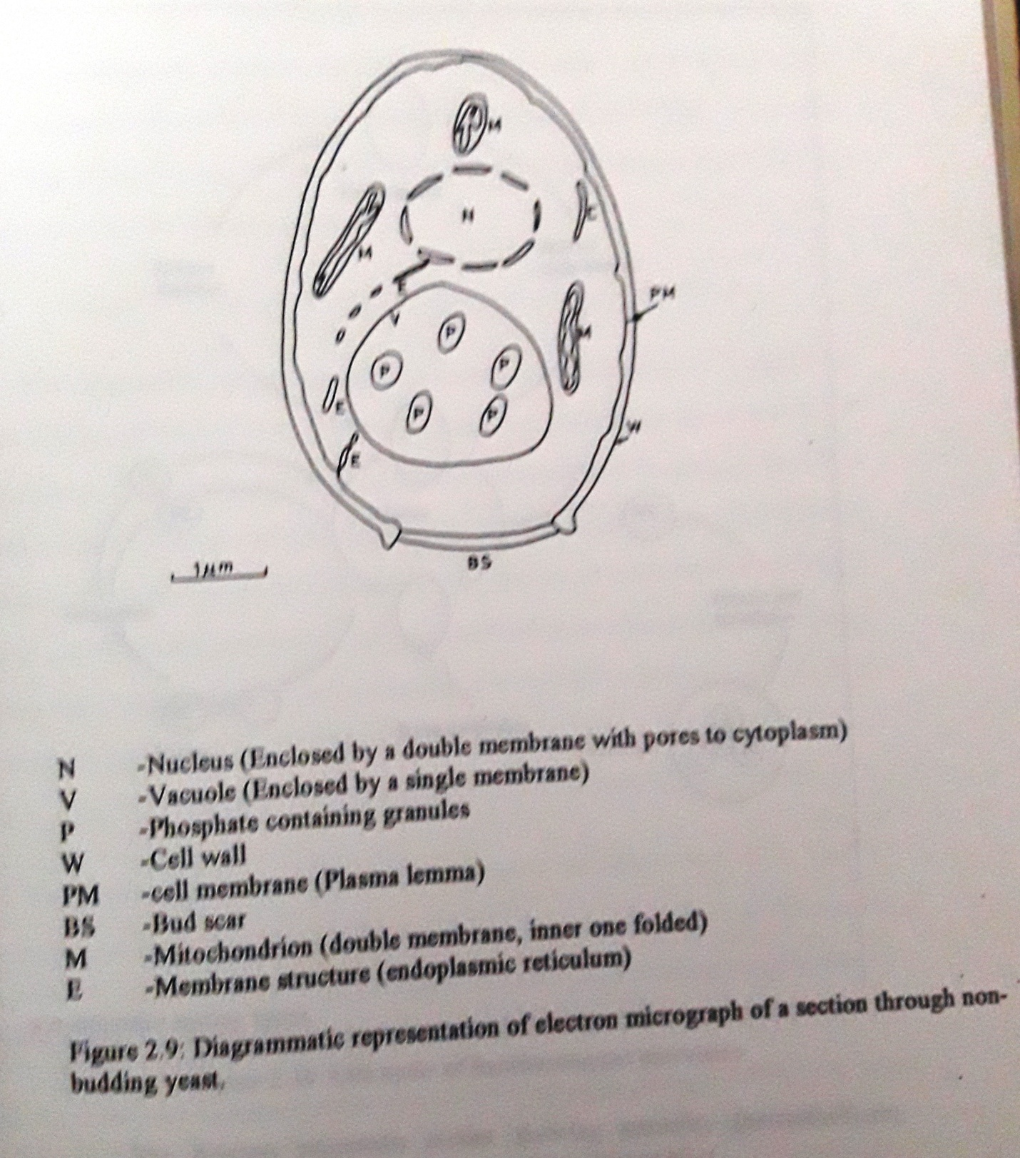

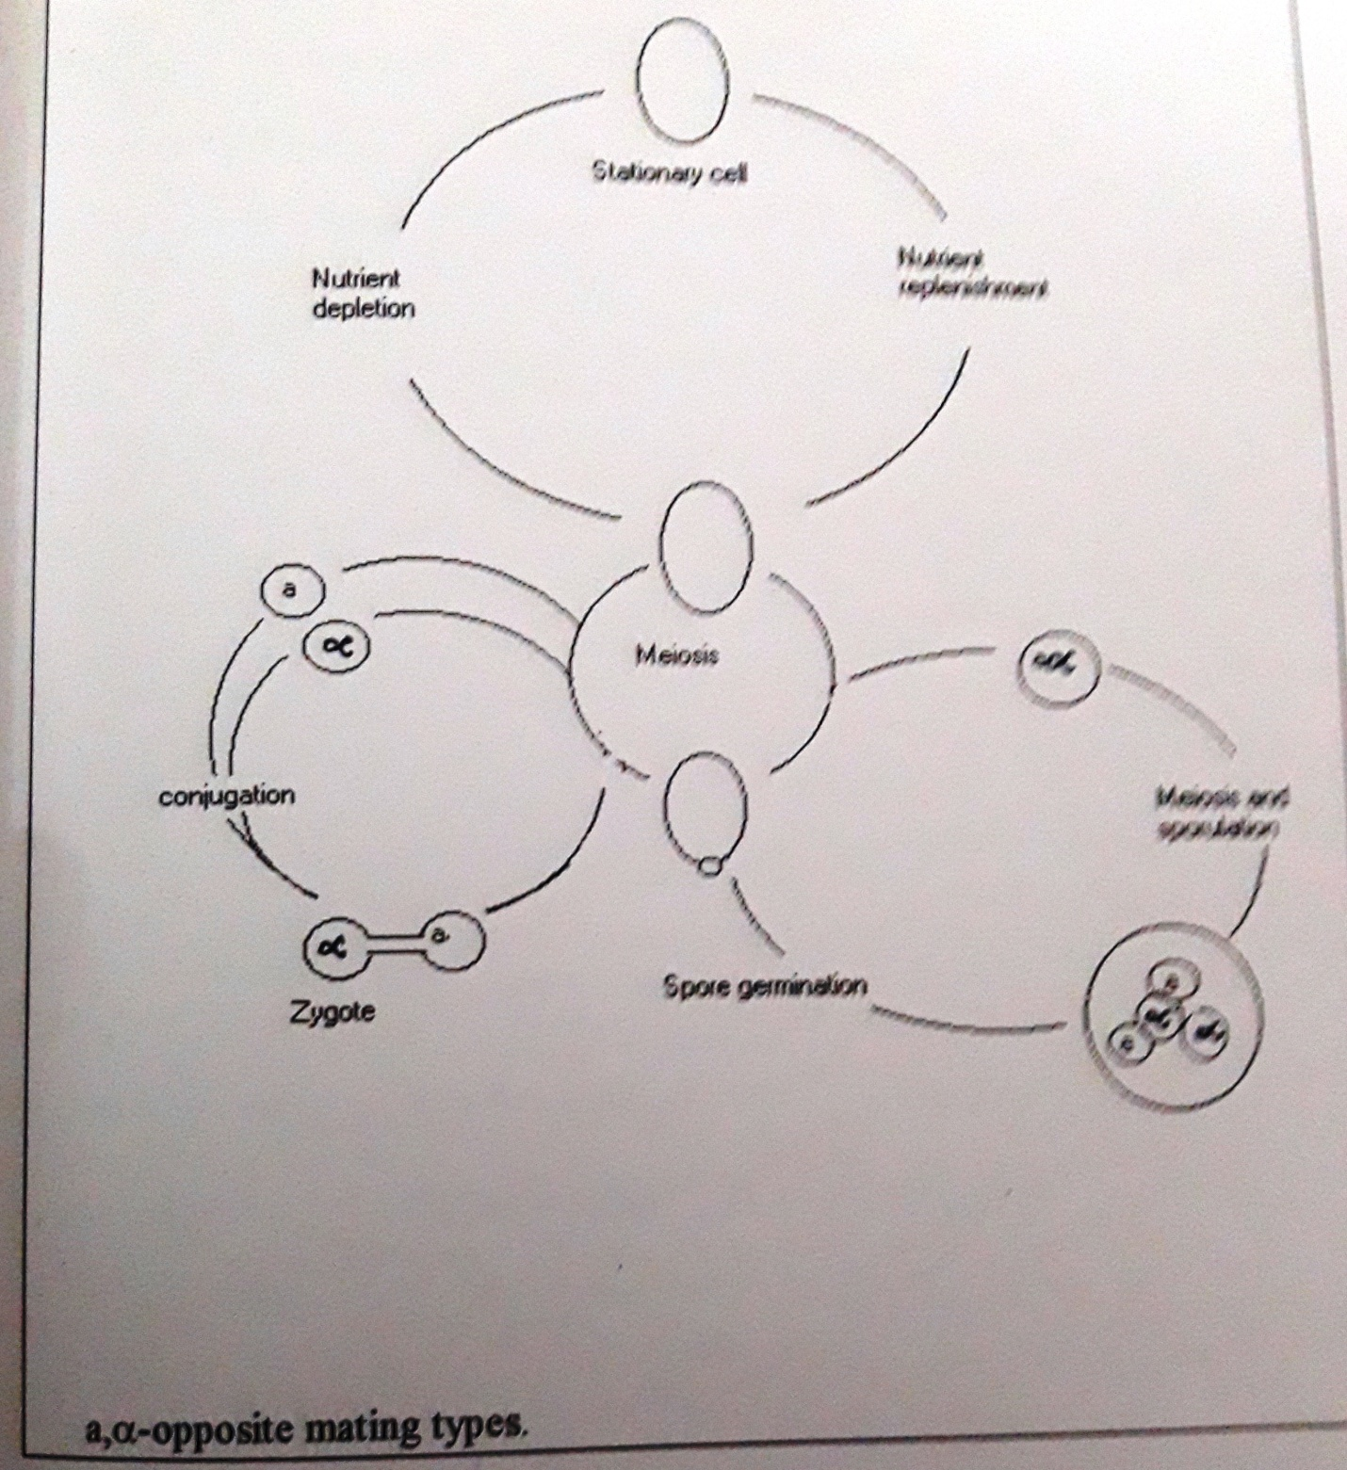

Figure 2.10. Life cycle of Saccharomyces cerevisiae
The diagram represents strains showing sexuality ( heterothallism); homothallic strains producing asci containing either a or all α.

Source- Michael J.Pelzar., 1977.
(Jagadish et al, 1977). The new born daughter cells is always smaller than its mother (Lord and Wheals, 1980) and this asymmetry of cell size at division increases with decreasing cell size at division increases with decreasing growth rate by Jagadish et al (1977), Lord and Wheals (1980) and Thompson and Wheals (1980). They also reported that the new born daughter cells must grow to a size before it begins a new cycle. These cells were reported to take longer times to grow than do their mother cells. The lower the growth rate, the larger will be the proportion of daughter cells in a culture of Saccharomyces cerevisiae (Jagadish et al, 1977). Thomas et al (1980), reported that ones the new daughter cell separates from the mother cell, both of them will grow and reach the same size at the same time and thus daughter cells grow much faster than their parent cells. The mother cells have a bud scar on their surface and this was identified by Beran et al (1967) using fluorescent techniques.
The identification key to the common ascosporogenous and non-sporing yeast genera is given by Kreger-Van Rij (1980).
In recent years genetically engineered yeast are being used. Saccharomyces cerevisiae SR93, is a recombinant strain which can be used to produce alcohol form starch instead of using mixed cultures or enzymes (Nakamura et al, 1997). The recombinant E.coli strains, which can ferment xylose and glucose to ethanol, and the various strains, which can convert xylose to ethanol were listed by Lisbeth Olsson and Barbel Hahn Hagerdal (1996). Ho Nam Chang et al (1997), used a recombinant strain having invertase activity for ethanol production.

2.12.3 Degradation of glucose by Saccharomyces cerevisiae
The anaerobic degradation of glucose was thoroughly studied by Lardy (1949) and Meyer Hof (1951). Yeasts may oxidaze the glucose by two major routes, 1) HMP pathway and 2) via the classical Embden – Meyerhof pathway. The oxidation of glucose via the hexose monophosphate (HMP) pathway was very well documated by Horecker and Mehler (1955). Reports also exist with evidences of acetate formation during glucose uptake and the HMP pathway is mainly responsible for oxidation of 0 to 30% glucose (Blumenthal et al, 1954) and that most of the CO₂ formed was as a result of glucose oxidation via this pathway (Beevers and Gibbs, 1954).
However, Eaton and Klein (1954) have indicated that it is not an important pathway of glucose degradation in young cells. Base studies using [3:4-C¹⁴] glucose confirmed that during aerobic degradation of glucose by resting cells of Saccharomyces cerevisiae, 80- 90% of the carbon at positions 3 and 4 of glucose were converted into CO₂ and the remaining was found as ethanol (Eaton and Klein, 1957). Studies on the growth of Saccharomyces cerevisiae anaerobically on glucose in chemostat culture, have shown that in addition to alcohol, substantial quantities of glycerol may also be formed along with some pyruvate (Fiechter et al, 1981).
2.12.3.1 Biochemistry of fermentation
Gay-Lussac (1851) established the fundamental changes in fermentation, which he summarized as one molecule of glucose yields two molecules of ethanol and two molecules of carbon dioxide.
C₆H₁₂O₆ 2C₂H₅OH + 2CO₂

Buchner brothers in 1897 showed that the juices from yeast cells perform the same fermentation process. In 1950, the biochemists Embden, Meyerhof, Robison, Neuberg, the Coris and Paranas succeeded in elucidating the mechanism of alcoholic fermentation which has been named as the Embden-Meyerhof-Paranas (EMP) pathway or the glycolytic pathway (Nord and Weis, 1958). The sequence of reaction is shown in figure. As per the Gay-Lussac’s equation, alcoholic fermentation of hexoses like glucose, fructose, galactose and mannose when fermented, 100kg of sugar will yield 51.142 kg (= 64.422 L) of 100 percent alcohol. The disaccharides like sucrose, maltose, lactose and melibiose which contain two hexoses on fermentation, 100Kg os sugar will yield 53.833kg (= 67.834 L) of 100 percent alcohol. In the polysaccharides like starch (or cellulose), 100kg of sugar will yield 56.824 kg (=71.603 L) of 100 percent ethanol (Albert Hansen et al, 1948).
The metal ions required for the expression of the enzymes activity are K⁺, Mg²⁺, Mn²⁺ etc. The yeast cells have to be provided with the consistent conditions of pH and temperature necessary for the enzyme activity. The over all reaction may be summarized as :
C₆H₁₂O₆ 2C₂H₅OH + 2CO₂ + energy

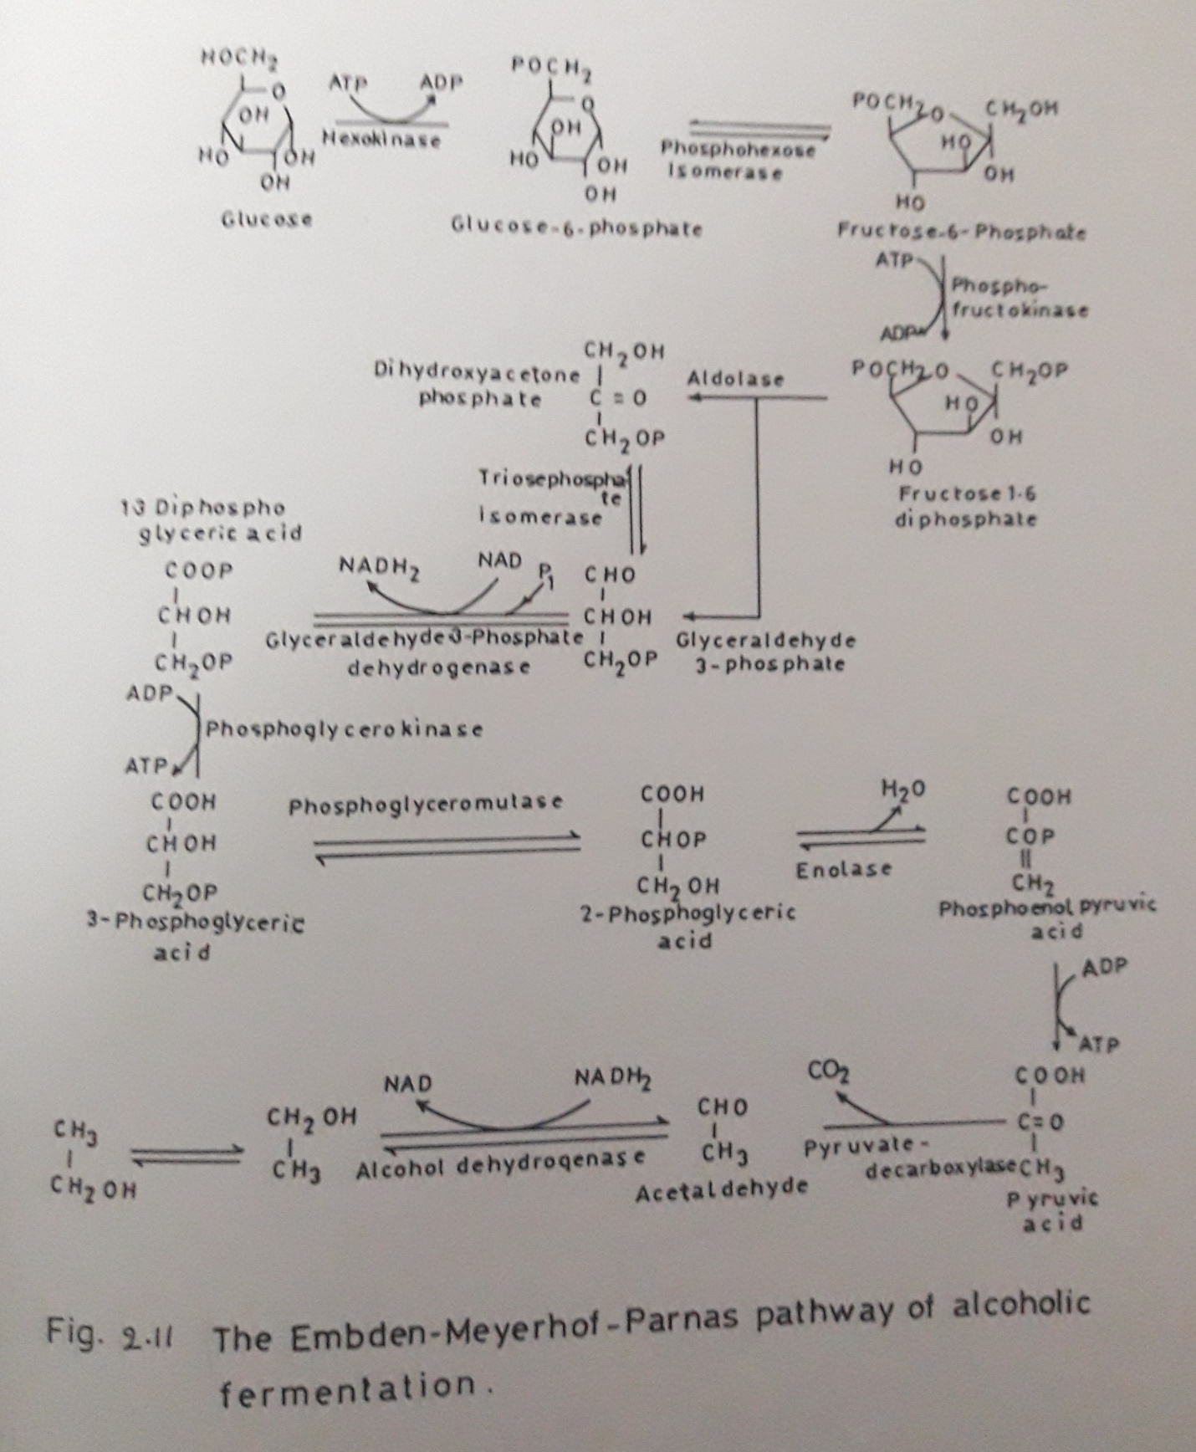

2.12.3.2 Explanation of the Biochemical reactions
The transport of glucose across the cell membrane is facilitated by a permease, which is a transport protein. Once the glucose enters the cells, it undergoes the following sequence of reactions.
- Glucose is phosphorylated to Glucose – 6 – Phosphate by the enzyme hexokinase. ATP donates the phosphate (P) ion.
- Glucose-6-P is converted to its isomeric form Fructose-6-P by the enzyme Phospho hexose isomerase.
- Phospho fructose kinase adds onemore phosphate from ATP resulting in fructose-1,6- diP.
- This 6 carbon molecule is cleaved into two 3-carbon molecules, the dihydroxy acetone phosphate and glyceraldehydes – 3 – phosphate by the enzyme aldolase. The interconversion of the two molecules is catalyzed by Phospho triose isomerase. As and when glyceraldehydes-3-P gets consumed during oxidation steps, the dihydroxy acetone phosphate gets converted to Glyceraldehyde-3-P, which participated in the next steps.
- Glyceraldehyde-3-P is oxidatively phosphorylated by glyceraldehydes-3-phosphate dehydrogenase to yield 1,3-diphospho glyceric acid and a molecule of NADH₂
- Phosphor glycerol kinase dephosphorylates the molecule to 3-phospho glyceric acid with the release of an ATP.
- Phospho glycerol mutase transfers the position of phosphate group and results in the formation of 2-phospho glyceric acid
- Enolase catalyzes the removal of water from 2-phospho glyceric acid to form phosphor enol pyruvic acid.
- This is dephosphorylated to yield pyruvic acid by the enzyme pyruvate kinase.
- Pyruvate decarboxylase removes CO2 from pyruvic acid in the presence of thiamine pyrophosphate and results in the formation of acetaldehyde.
- Alcohol dehydrogenase catalyzes the final step to form alcohol from acetaldehyde. A molecule of NADH₂ is consumed in this reaction.

The ATP consumed and released in the reaction are :
Step | Energy form (+) released/consumed (-) | ATP
1 | ATP consumed | -ATP
3 | ATP consumed | -ATP
5 | NADH₂ consumed | 2 x 2 ATP
9 | 2ATP released | 2 ATP
11 | NADH₂ consumed | 2 x 2 ATP
 | Net Yield | 2 ATP

Thus two ATP are produced per molecule of glucose and the reaction is exothermic as 56,000 calories (240KJ) of energy per mole of glucose are potentially available and 2 x 8000 calories are retained as ATP. The efficiency of the process is around 29%. This ATP is used both to maintain itself and produce new cells. If no respiration occurs, the amount of ATP released is directly proportional to the amount of glucose oxidized (Warren et al, 1990). The characteristic rise in temperature during fermentation is due to the energy not retained by the cells and is list as heat.
When Saccharomyces respire (when air is supplied) complete oxidation of glucose takes place with the liberation of 686,000 calories (2.9 MJ) per mole of glucose. This happens only when sugar concentration is very low (<1.0%). There can be a modification of the permesae affinity for glucose in cultures when sugar is totally exhausted and the cells start to use ethanol as the substrate (Walsh, 1994a). In yeast the diauxic shift is found, since glucose is primarily metabolized fermentatively, even in the presence of ethanol and oxygen. Only when glucose is exhausted will the cells shift to metabolism of ethanol, the quantitative aspect of the signaling is illustrated by the fact that in glucose-limited chemostat, where the steady-state concentration of this compound remains low, both glucose and ethanol are metabolized simultaneously (Postma et al, 1988). Rizzi et al (1996), studied the effect of glucose-6-phsphate within the cells on glucose transport at different process conditions in continuous cultures.
2.12.4 Fermentation of other sugars
Of all the microorganisms being used in brewing Saccharomyces cerevisiae and related species have greater applicability of their ability to rake up and ferment a wide range of sugars, for eg. Sucrose, glucose, fructose, maltose, galactose, mannose and maltotriose.
- Fructose- it is phosphorylated by hexokinase to fructose – 6- phosphate
- Galactose – Converted back to glucose – 6 – phosphate by a series of reactios
- Sucrose- It is hydrolysed to glucose and fructose by the enzyme invertase extracellularly
- Maltose – It is transported into cells by a permease and them hydrolysed to glucose molecules by the enzyme maltase.
Maltose is not absorbed in yeast cell by simple diffusion (Harris and Thompson, 1960), but is actively transported inside the cell before utilization by a permease (Sols and de la Fuente, 1960). According to Milln (1963), sucrose and monosaccharides of brewer’s wort are fermented first, followed by maltose and then maltotriose.

2.12.5 Effect of fermentation by yeast
The physical parameters as well as the chemical parameters effecting the ethanol production by yeast are as follows.

2.12.5.1 Effect if substrate concentration
It is a known fact that a molecule of glucose yields two molecules of ethanol and two molecules of carbon dioxide. At very low substrate concentration the yeast is starved and the productivity decreases. At a reducing sugar concentration of 30% (w/v), the substrate concentration showed an inhibitory effect on the yeast growth as well as on the rate of ethanol production (Ghose and Tyagi, 1979). Many scientists have reported the same inhibitory effect and it is attributed to the high osmotic pressure caused due to high sugar concentration (Franz and De Nahrung, 1961, Pironti, 1971).

2.12.5.2 Effect of ethanol concentration
Saccharomyces cerevisiae has developed remarkable ethanol- tolerance during these thousands of years and it has adopted itself very well to ethanol. Maximum allowable concentration of ethanol is around 10%(w/v) for growth and 20%(w/v) for ethanol production for most of the tolerant strains (Gray, 1941; Troye, 1953 and Ranganathan and Bhat, 1958). Ethanol inhibition is directly related to the inhibition and denaturation of important glycolytic enzymes, as well as to the modification of cell membrane (Rose and Bevan, 1981 and Miller et al, 1982). It also inhibits the maltose and glucose transport across the plasm membrane (Thomas, 1978; Thomas and Rose 1979; Beavan et al, 1982). At very high ethanol concentrations, ethanol accumulates in the cells and kills them (Noval et al, 1981). Usually 12% sugar utilization is preferable in order to balance between economic distillation of alcohol and inhibition of the fermentation by the product (Greenshields, 1974).

2.12.5.3 Effect of oxygen
It is a well known fact that oxygen inhibits ethanol production, still, a very low concentration of oxygen is required by the yeast to maintain cell viability. At high aeration conditions (100ml.min), the ethanol yields have reduced, as well as total sugar consumption was also reported to be reduced. The reason may be that the high aeration rates either shift the yeast fermentation towards production of more oxidized products or it may have caused ethanol volatilization (Gas stripping) or it may have enhanced ethanol oxidation (Gill et al, 1991). The growth rate of Saccharomyces cerevisiae is also increased with increase in dissolved oxygen concentration. Dissolved oxygen concentration in the range of 5-10 parts per billion was shown to increase the specific ethanol production rate over the rates under anaerobic condition (Grosz, Rong 1981). Addition of small amounts of oxygen is shown to increase the percentage of unsaturated fatty acids in the plasma membrane as well as the total number of fatty acids (Rogers and Stewart, 1973), which increased the ethanol tolerance of the cells (Thomas and Rose, 1978).

2.12.5.4 Effect of pH
Most strains of Saccharomyces cerevisiae have been reported to exhibit a broad range of pH between 2.4 and 8.6. Optimal growth is usually reported at pH 4.5 (Jones et al, 1981). In case of fermentations using grains a pH in the range of 4.8 to 5.0 is used (Under Kofler and Hickey, 1954). The low pH is selected to prevent bacteria from contaminating the medium. To control the internal pH between 5.8 and 6.3 of the cells, the external pH of the medium should be in the range from pH 3.0 to 7.0 (Martin, 1972).

2.12.5.5 Effect of temperature
Most of the yeast strains exhibit optimum growth rates in the remperature range 28ºC to 35ºC (Gray, 1941), while the maximum temperature that the yast can tolerate is 40ºC (Haukeli and Lie, 1971; Wlash and Martin, 1977). Barley beer production is usually carried out between the temperatures 10ºC to 20ºC (Pickrell, 1986a) to reduce the fusel oils formation. The optimum temperature for growth and fermentation are usually strain dependent. Yeasts can be stored inactive at low temperatures (>0ºC) and are readily revived (Stark, 1954).

2.12.5.6 Effect of Inoculum level and Inoculum age
The fermentation processes are greatly influenced by the yeast inoculums level and also inoculums age (Birol, Gurnur and Ozergin-Ulgen, Kultu 1955). The inoculum level also affects the fermentation rate a cell number of approximately 10⁷ cells/ml or 0.1% (w/v) of compressed yeast have to be used to get good results (Rose and Harrison, 1970). At higher yeast concentrations the alcohol content increase but it is also reported to affect the fusel alcohol content (Watson and Hough, 1966).

2.12.6.1 Effect of Chemical Parameters or Nutrients
In addition to the carbohydrate source, the fermented mash has to be supplemented with secondary nutrients, which are essential for the cell maintenance and growth (Jones et al, 1981).

2.12.6.1 Nitrogen source
Yeast cells utilize NH₄⁺ ions as the sole source of nitrogen. (NH₄)₂SO₄ is widely used and its concentration varies with the substrate (de Mancilha et al, 1984; Parisi et al, 1986; Gil et al, 1991). The addition of (NH₄)₂SO₄ to high tannin grain sorghum has been reported to increase ethanol production rate (Thomas Mullins, 1987). NH₄Cl was also used in few works (Gerald R.Cysewski, 1977). Urea may also be used as nitrogen source (alcohol manufacture, 1981). Few complex nitrogen sources used by different authors include peptone(Isidoro Gracia Gracia et al, 1989), polypeptone (Sang Yeol Lee et al, 1993), cron steep liquor (Tremiane, 1956), dry barley malt (Fertman, 1962), albumin hydrolysate (Shin, Chul Soo et al, 1995), manure (Lampty et al, 1986), soya bean oil (Aherthum and Cruz, 1987), skim milk (Patil, 1986) and cheap nitrogen source (CNS-11) (Patrice Vienne, 1983). The effect of nitrogen sources on sporulation was studied by Tremaine (1956). Simple aminoacids can be used as nitrogen sources (Barton-Wright, 1952).
The other growth factor, which contribute nitrogen, include purines, pyramidines (Bokhodler, 1944), ergosterol (Andrason and Stier, 1953) ergosterol and oleic acid (Casey et al, 1984), vegetable oils (Saigal Deepak and Vishwanathan, 1984) etc.
Brewers wort generally contains 65 to 100mg nitrogen per 100ml, which includes aminoacids to high molecular weight polypeptides. Based on the rate of absorption of aminoacids from the wort, they are classified into four categories as listed in table 2.12. The pathway for the assimilation of nitrogen sources is shown in figure 2.12.
Senthashanmugathanan (1960) showed that glutamic acid plays the key role in transfer of –NH₂ group from α-aminoacids for the synthesis of aminoacids by yeast.

2.12.6.2 Yeast extract
Yeast extract is a water soluble extract of autolyzed yeast. it contains around 14% carbohydrate and various amino acids (Rohne, 1973), which can easily be used to build new yeast cells. It also contains small quantities of purines, pyramidines, vitamins as well as minerals. The stimulation was greater when pure aminoacids mixtures were added, instead of yeast autolyzate (Enebo and Johnson, 1965). Similarly, if wort contains 250mg of α-amino nitrogen per liter, yeast extract showed no stimulation.

2.12.6.3.1 Phosphorus
Phosphorus is generally provided in the form of a phosphate (H₂PO₄⁻). It may be added as an acid H₃PO₄⁻(de Mancilha et al, 1984) or a salt of potassium, say KH₂PO₄ (David Williams and Douglas M.Munnecke, 1981) or sodium, i.e., NaH₂PO₄ (Siva Kesava et al, 1996) or ammonium phosphate (NH₄)₂HPO₄ (Staphanie Bringer et al, 1984). H₂PO₄⁻ plays critical role in cell growth (Soumalainen and Oura, 1971) and glycolysis (Uyeda and Racker, 1965). Phosphate is assimilated into the cells by an active transport mechanism (Ramsay and Douglas, 1979).

2.12.6.4 Other anions
Sulphur is an important anion for the aminoacid methionine formation and is met by the usage of ammonium sulphate. Low concentration of Cl⁻ and I⁻ are also necessary to stimulate the growth (Souma lainen and Oura, 1971; Morris, 1958).

Table 2.12: Classification of amino acids based on their rate of absorption from wort
Group | (1) | (2)
Group A  (Fast Absorption) | Asparagine  Serine  Threonine  Lysine  Arginine  Glutamic acid  Aspartic acid  Glutamine | Asparagine  Serine  Threonine  Lysine
Group B  (Intermediate rate of absorption) | Valine  Methionine  Leucine  Isoleucine  Histidine | Arginine  Aspartic acid  Glutamic acid  Valine  Methionine  Leucine  Isoleucine
Group C  (Slow absorption) | Glycine  Phenylalanine  Tyrosine  Tryptophan\ammonia  Alanine | Histidine  Glycine  Phenylalanine  Tyrosine  Tryptophan  Ammonia
Group D  (Little or no absorption) | Proline | Alanine  Proline

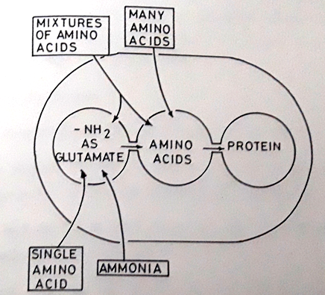
Figure 2.12: Schematic representation of the efficiency of various nitrogen sources for protein synthesis and yeast growth

The pathways are shown for ammonia, for single aminoacids, for mixtures of several aminoacids and for a complete mixture of aminoacids.

Source: Lewis, 1964.

2.12.6.4 Effect of metal ions
The trace elements fall into three categories (Rose, 1976).
a) Macro elements (K, Mg, Ca, Zn, Fe, Mn, Cl) required in the concentrations of 0.1 to 1mM and taken up by facilitated diffusion.
b) Micro elements (Co, B, Cd, Cr, Cu, I, Mo, Ni, Va) required in the concentrations of 0.1 to 100μM, and
c) Inhibitors (Ag, As, Bd, Hg, Li, Ni, Os, Pd, Se, Te) where concentrations greater than 10 to 100 μM affect growth and fermentation adversely.
The effect of different cations and their stimulatory effect on growth and fermentation by yeast is extensively listed by Jones and Green Field (1984). The role of few inorganic nutrient and their approximate concentrations required for the growth of 25g of yeast per litre islisted in table 2.13.
Supplementing the wort with 0.003M concentration of Ca²⁺ and Mg²⁺ resulted in maximum fermentation (Atkin and Gray, 1962). Yeast requires 0.018M potassium whereas a minimal amount (20ppm) is required (Buday et al, 1966). Densky et al (1966), showed that worts containing 0.05 to .10ppm Zn when supplemented with final concentration of 0.5ppm Zn stimulated the growth of yeast. Antagonism between different metal ions has also been studied. Helen and Slaughter (1977) studied the antagonism between Zn²⁺ and Mn²⁺ and Zn, Mn²⁺ and Cd²⁺. Similarly studies were also carried out between K⁺ and Li⁺ (Asensio et al, 1976). Wong (1983), developed a totally defined synthetic medium to get high ethanol yields. The medium comprises of glucose, (ΝΗ₄)₂SΟ₄ as the nitrogen source, trace elements and vitamins.

2.12.6.6 Vitamins
Vitamins are required to act either as coenzymes or as precursors for the fully acive enzyme. Biotin and Calcium pantothenate are widely used in ethanol fermentation (Staphanie Briner et al, 1984; Hugh G.Lawford and Niels Sternborg, 1986; Kademi et al, 1996). Thiamine and pyridoxal increase the specific ethanol productivity, while thamine may also contribute to increased ethanol tolerance (Rahn, 1952). The role of B vitamin on the rate of alcohol fermentation was extensively studied by Saburo Fukui et al(1955). P-amino benzoic acid (PABA) and thiamine at very low concentration were reported to increase the glucose uptake rate by yeast (Dhar, 1957). At concentrations above (approximately 25γ/ml) PABA showed
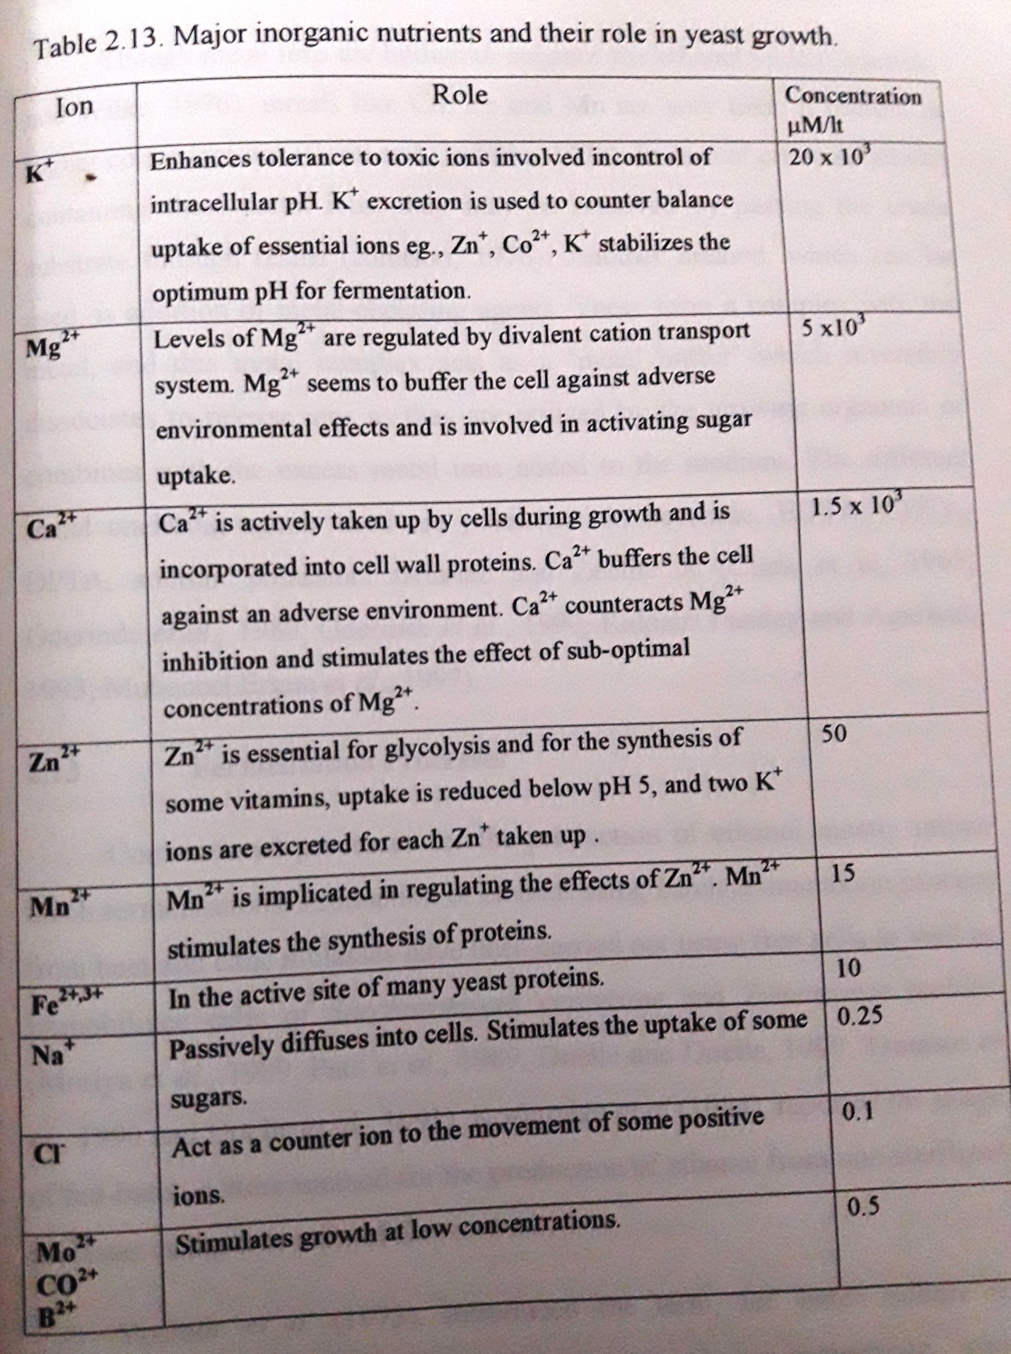

inhibitory effects which may be overcome by the addition of aromatic aminoacids (Lester J.Reed et al, 1959). The requirement for various vitamins is also temperature dependent (Amana and Takeuchi, 1961).

2.12.6.7 Metal chelating agents
Though metal ions are known to enhance the ethanol yield (Cysewski and Wilke , 1976), meals like Cu, Zn and Mn are very toxic if present in higher concentrations (Gadd and Graffiths, 1978). In case of crude substrates containing these metal ions, they may be removed by passing the crude substrate through resins (Johnson, 1976). Another method, which can be used is addition to metal – chelating agents. These form a complex that acts as a metal buffer, which reversibly dissociate to release ions as they are utilized by the growing organism or combines with the excess metal ions added to the medium. The different metal chelating agents used are potassium ferrocyanide, EDTA, CDTA, DPTA, sodium potassium tartarate and Zeolite X (Clark et al, 1965; Oderinde et al, 1980; Oderinde et al, 1990; Kalpana Pandey and Agarwal, 1993; Mubeccel Ergun et al, 1997).

2.12 Fermentation Processes
Conventional processes for the production of ethanol mostly utilize batch fermentations. Production of ethanol using batch fermentation process from beet and cane molasses have been carried out using free cells as well as mobilized cells of saccharomyces cerevisiae and Zymomonas mobilis (Moriya et al, 1989; Patil et al, 1989; Doelle and Doelle, 1990; Tsoutsad et al, 1990 and Doelle et al, 1991). Kshimizu et al (1984), reported the usage of fed-batch culture method for the production of ethanol from non-sterilized molasses using free cells of S.cerevisiae.
Yoshida et al (1973), introduced the term, fed batch culture to describe batch cultures which are fed continuously, or sequentially, with medium and without the removal of culture fluids. The production of ethanol by fed batch processes was done using non-sterilized beet molasses as well as sugar cane black strap molasses using both free and immobilized cells (Kruate etal, 1987; Carvallo et al, 1990; Roukas, 1996). The Fed-batch culture process has several advantages over the conventional batch processes (Stanbury and Whitkar, 1984),which include, very low concentration of residual sugars, higher dissolved oxygen in the medium, decreased fermentation time, higher productivity and reduced toxic effect of the medium components which are present at higher concentrations.
In recent trends, continuous ethanol production has been gaining importance. Continuous fermentation is a steady state fermentation system that operates without interruption. Each stage of fermentation occurs in a separate section of the fermenter and flow rates are set to correspond with required residual time. The advantages of this continuous flow process over the conventional batch process is the reduced cost of the bioreactor construction, reduced maintenance and operation requirement, better process control and increased productivity (Guido boni, 1984). These are achieved by using high cell densities. The cell recycling processes (Kuriyama et al, 1985; Lee and Chang, 1987) and cell immobilization techniques in different solid matrices help in achieving high cell densities.
2.14 Immobilization of Saccharomyces cerevisiae
The different methods for immobilization are adsorption, covalent bonding, cross linking,, entrapment and encapsulation. Few of the different matrices used for ethanol production by immobilized whole cell system are shown in table 2.14. The immobilized organism is packed in the reactor and the feed is introduced from the bottom and the fermented broth is collected from the top. The main purpose of immobilization is the reusability of the organism and easy recovery of the product.
2.15 Reactor design
Bioreactors of different configuration have been designed to get efficient conversion eg., tapered bioreactor ( Hamamchi and Ryu, 1987), rotational biological contactor (Coverti et al., 1987), plate, spiral and bee hive- type as well as bead surface bioreactor (Qureshi et al., 1987), have been used for ethanol production. The commonly used bioreactors are the vertical packed bed reactors and the continuous stirred tank reactors (Ryu et al., 1981; Gencer and Mutharasan, 1983). Alginate immobilized yeast beads were used for ethanol production using a fluidized bed bioreactor (Christopher D. Gilson and Adrian Thomas, 1995). Column with perforated plates (Grote et al., 1980), horizontal packed beds ( Maragaritis et al., 1981) and rotating packed drum (
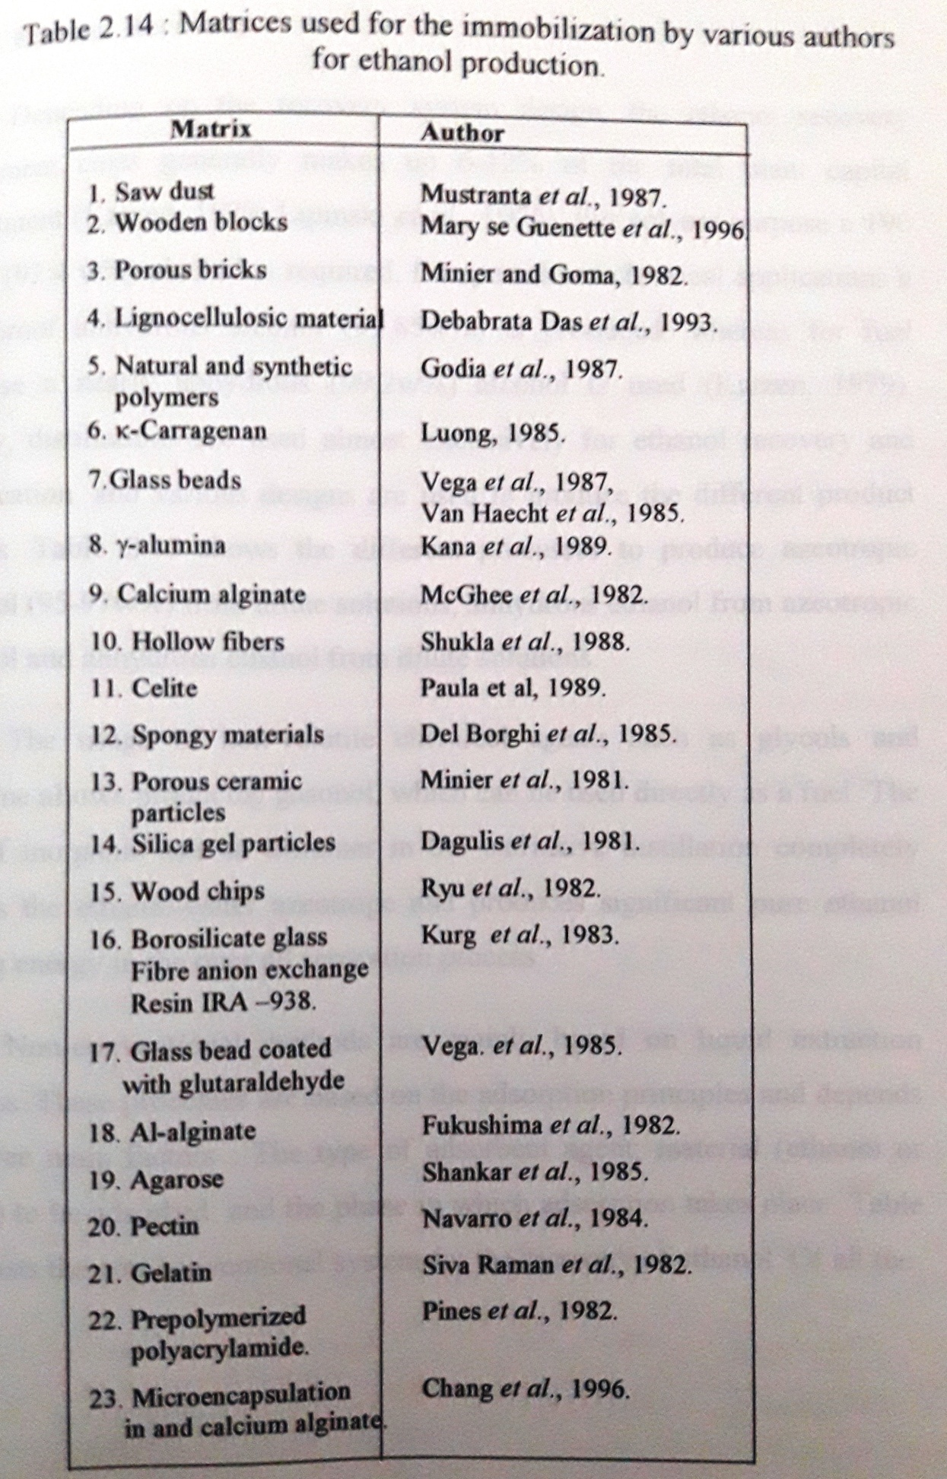
Lee and Chang, 1985). Biofilm bioreactors with polypropylene composite supports containing around 25% (w/w) of various agriculture materials were reported to give 3 to 8 fold increase when compared to suspension culture fermentations using free cells (Kunduru Reddy and Pometto, 1996). A vertical rotating immobilized bioreactor with entrapped Zymomonas mobilis was used for continuous ethanol production (Amin and Doelle, 1990). The optimization of different parameters, which affects the rate of fermentation in cylindro- conical fermentors, was done by Hoggan (1977). Ethanol fermentation using immobilized cells in a multistage fluidized bed bioreactor was done by Tzeng et al (1991).
2.16 Ethanol Recovery
Depending on the recovery system design, the ethanol recovery equipment costs generally makes up 6-12% of the total plant capital investment (Katzen, 1979; Lipinski et al., 1976). For solvent purpose a 190 proof (92.4 w%) alcohol is required for specialized chemical applications of 200 proof anhydrous alcohol (99.85w%) is produced, whereas for fuel purpose a nearly anhydrous (99.2%w) alcohol is used (Katzen, 1979). Today, distillations are used almost exclusively for ethanol recovery and purification, and various designs are used to produce the different product grades. Table 2.15 shows the different processes to produce azeotropic ethanol (95-95%w) for dilute solutions, anhydrous ethanol for azeotropic ethanol and anhydrous ethanol from dilute solutions.
The usage of non-volatile chemical agents such as glycols and gasoline allows producing gasoline, which can be used directly as a fuel. The use of inorganic salt as entrainer in the extractive distillation completely breaks the ethanol-water azeotrope and produces significant pure ethanol saving energy in the overall separation process.
Non-conventional methods are mainly based on liquid extraction process. These processes are based on adsorption principles and depends on three main factors: The type of absorbent agent; Material (ethanol or water) to be absorbed; and the phase in which adsorption takes place. Table 2.16 lists the non-conventional system for the recovery of ethanol. Of all the procedures the energy usage is very less when cellulose and corn meal were used for adsorbents. Next comes the catalytic conversion method. Matsumura et al (1986), reported the usage of prestraction process, which is solvent extraction through a membrane. This is coupled with
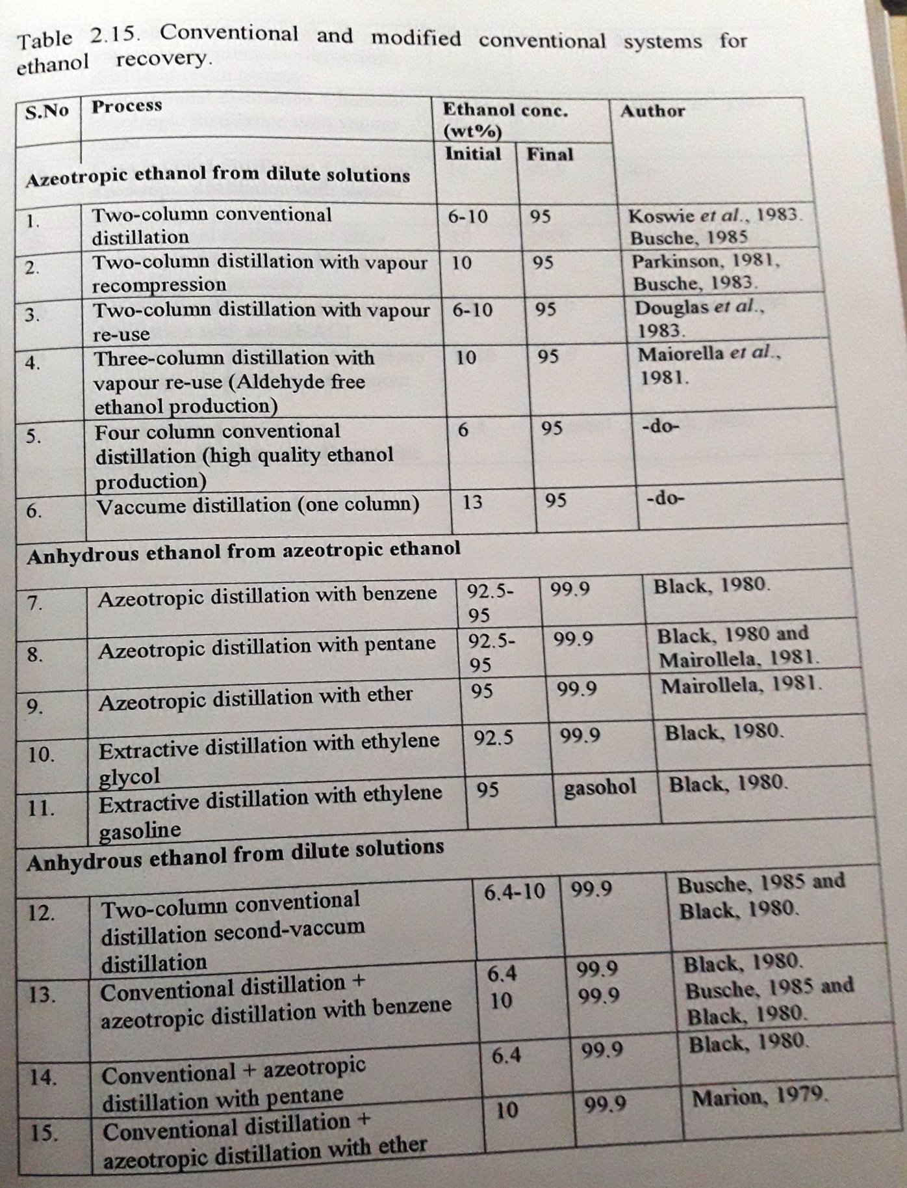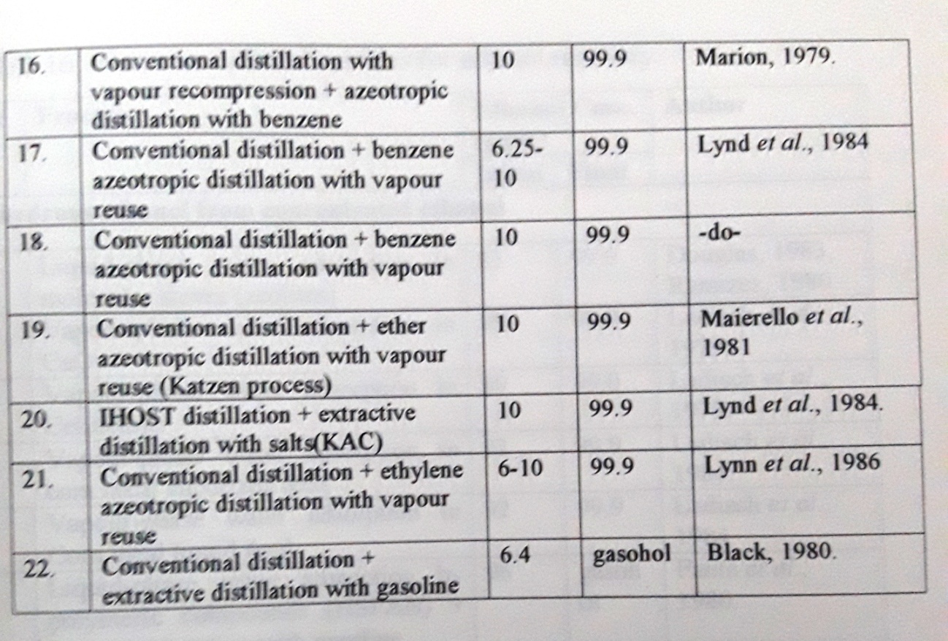

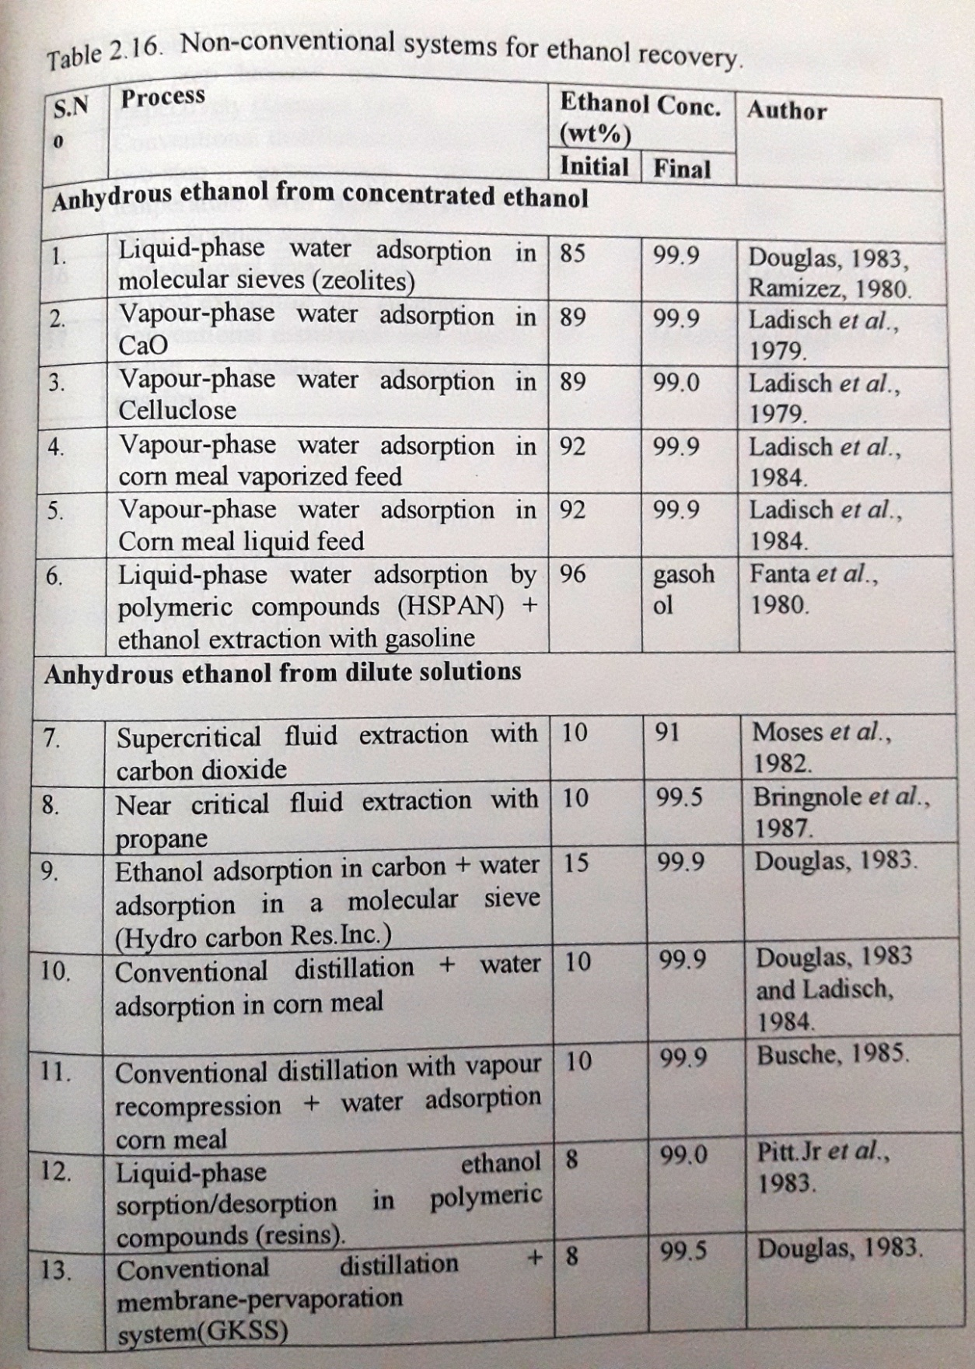

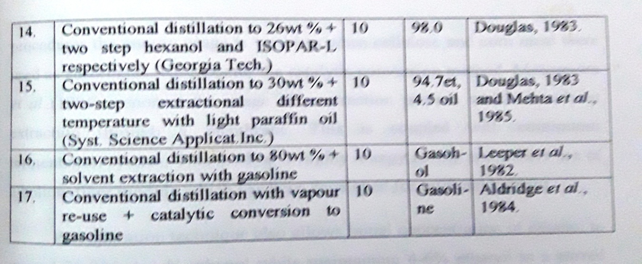

continuous fermentation system. This method is highly energy saving and makes use of a hollow fiber module which has been developed for artificial kidneys.
Pervaporation technique also allows initial concentration of ethanol to aroud 20-23 (w/w) % ethanol while maintaining 4-6% ethanol in a stirred tank fermentor (O’Brien et al., 1996). Its development began in 1950’s (Binning et al., 1991) and its application for ethanol recovery was done by Beanmelle et al (1993).
2.17 Fusel alcohols
It is a well known fact that ethanol fermentation also results in fusel alcohols formation. These are mainly isobutyl, isoamyl and amyl alcohol (Aries, 1947; Harrison and Graham, 1970). The fusel alcohol contents is reported to be in the range of 39-232 ppm for English beer (Stevens, 1960), 250-374 ppm for California wines (Guymon, 1952), 215 – 1350ppm for grape brandy and 320-2760 ppm in Scotch Whisky ( Steven, 1960). O’Donovan and Novellie (1966), reported that kaffir beer contains around 227 ppm fusel oils. Therefore the content of fusel oil varies and it is produced at a rate of 1-5 liters per 1000L of alcohol ( Suomalainen and Ronkainen, 1968). The formation of fusel alcohols by baker’s yeast was investigated by Suomalainen and Kahanpaa (1963). The reports show that L-Valine, L-Leucine and L-Isoleucine, which are the branched chain amino acids are actively involved in fusel alcohol formation.
2.18 Physical properties of ethanol (Krik and Other, 1978; British pharmacopoeia, 1993).
Ethanol is a clear, mobile and highly volatile and hygroscopic liquid. It has a characteristic odor and produces burning sensation on tongue. It is easily soluble in water, ether, chloroform and glycerol. The properties of ethanol are listed in table 2.17.
2.19 Identification tests for ethanol
a) Mix 5 drops of 95% ethanol in a small beaker with 1ml of potassium permanganate solution and 5 drops of dilute sulphuric acid and cover the beaker with a filter paper moistened with a solution recently prepared by dissolving 0.1g of sodium nitroprusside and 0.5g of piperazine hydrate in 5ml water; an intense blue color is produced on the filter paper and the color becoming paler after a few minutes.
b) To 5 ml of a 0.5% solution, add 1ml of 0.1N sodium hydroxide; then slowly add 2 ml of iodine solution; the odour of iodoform develops and a yellow precipitate is produced.
2.20 Qualitative tests for ethanol
The qualitative tests for the estimation of alcohol in dilute solutions are usually simple, rapid and can be used, provided only one is present at a time. There are two important methods worth mentioning, 1) Colorimetric determination using Ceric ammonium nitrate and 2) Permanganate test by spectrophotometer
1) Colorimetric determination of alcohols (Reid and Truelove, 1952)
Reagent- Ceric ammonium nitrate reagent- 20g of salt in 4N HNO₃. The reagent is standardized before use;
Procedure- To 5 ml sample, 2 ml of ceric reagent is added. For the preparation of blank, 5 ml of distilled water is sued. After exactly 5 minutes, the absorbance is read using Olive-green filter. The difference in OD is noted down.
A calibration curve is prepared using known amount of samples. The amount of alcohol for the unknown is read from the standard graph. The rate of increase in OD varies for each alcohol.
2) Permanganate test for alcohol quality (Rask and Hilde brandt, 1947)- In this method, the permanganate reduction time of alcohols will indicate whether the sample is pure or it has any fusel oils.
Reagent- 0.02% permanganate solution in water
Procedure- 250ml of the alcohol solution 2 cc of permanganate solution is added and the change in the absorbance is read at 540 mμ for every 2 minutes. A transmittance- time curve is drawn. The slope of the straight line obtained is characteristic of the alcohol under the test. The quality characteristics of the alcohol can be obtained from the slope – intercept straight- line equation-
y = mx + b(1)

Where, y = percent transmittance
x = elapsed time in minutes when transmittance is observed
m = rate of decolourization or slope of line
b = intercept of line on Y – axis
The m and b values vary when any impurities are present in the alcohol sample.
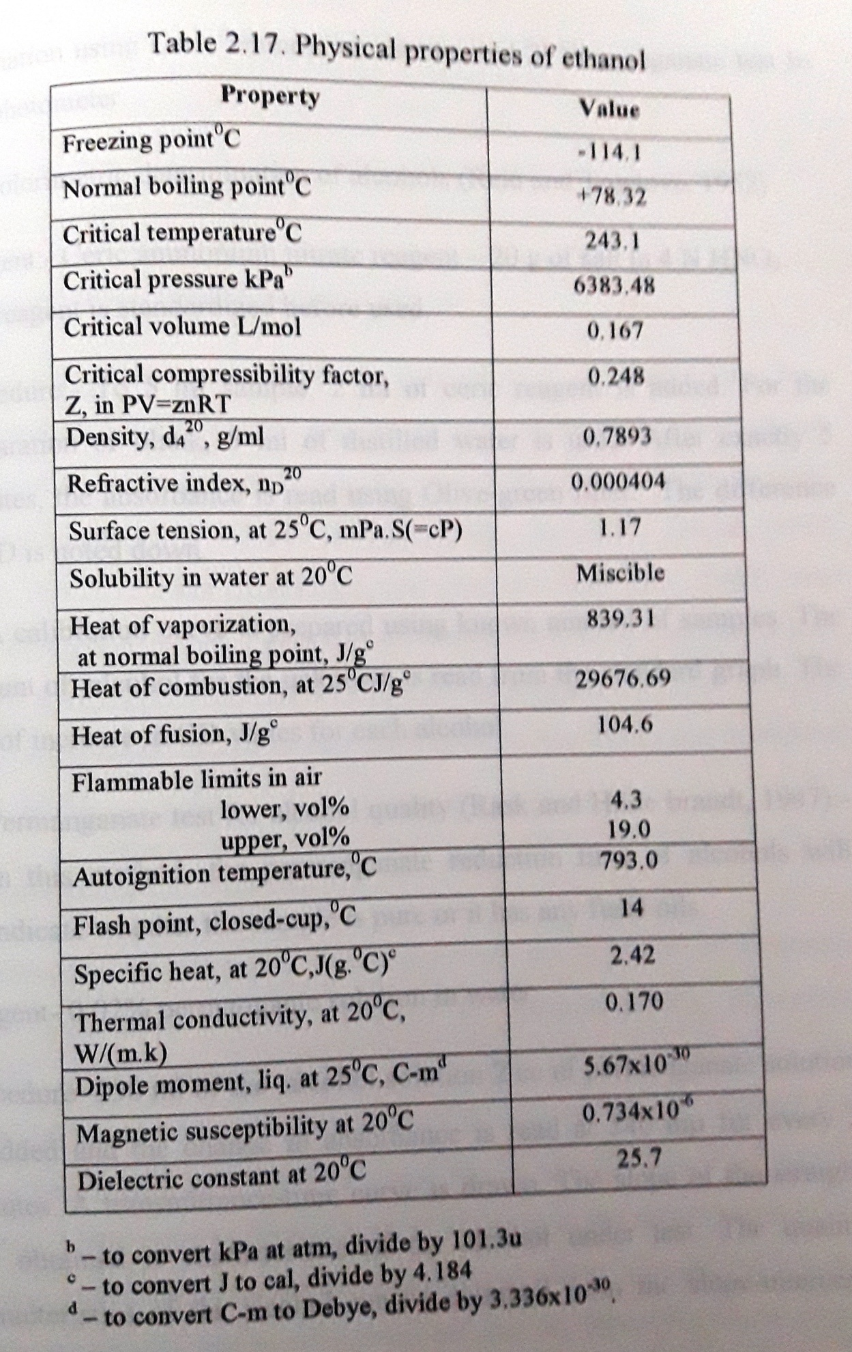
2.21 Quantitative determination of ethanol
Many quantitative methods for the determination of ethanol have been developed during these years to give the accurate percentage concentrations. The estimation methods include specific gravity method (William Horwitz, 1980), refractometric (William Horwitz, 1980), titrimetric ( Neish, 1952; Kubiek, 1963; Arthur Caputi, Jr and Dawson Wright, 1969) and chromatographic methods. The recent advancement in the development is an automatic multicommutated flow system for ethanol determination which is based on dichromate reduction reaction ( Comitre Ana Lucia and Reis, Boe-Ventura, 2000).

2.22 Applications of ethanol
Ethanol is an important industrial solvent and it is also an important chemical feed stock for the synthesis of pharmaceuticals, detergents, adhesives, plastics and plasticizers and a host of other chemicals. The chemicals that can be derived from ethanol are shown in figure 1. Ethanol also finds its application as a fuel, beverage and in therapeutics. Fuel alcohol production is the most interesting area of research in the recent scenario. As a beverage it was reported to reduce the risk of atherosclerosis and cataract in people consuming one alcohol drink per day by 50% ( Trevithick et al., 1999).

